Population aging in the ESCAP region and its economic and intergenerational consequences

Ronald Lee
2933 Russell St.
Berkeley, CA 94705
USA
T: 1 510 685 3727
E: ronaldlee1941@berkeley.edu

Abstract (150 words?)

Key words: (3 or more, compound ok)

Demographic trends and Demographic Transition
The “demographic transition” is a valuable framework for understanding, interpreting, and projecting the demographic changes that a country’s population undergoes as it moves from high fertility and high mortality before the transition to low fertility and low mortality after. Throughout this transition there are important changes in the population growth rate, which first rises and then falls, and the population age distribution. The age distribution before the transition is very young, with many children and few elderly. Initially mortality declines while fertility remains high, leading to increased child dependency as more births survive. Then, once fertility begins to decline, child dependency declines and the share of the population in the working ages rises, giving rise to the so-called (first) demographic dividend, which boosts the growth rate of per capita income. Eventually, though, the lower fertility leads to slower growth of the working age population while the elderly population continues to grow: population aging begins and the “chronological” old age dependency ratio begins to rise (the ratio of the population age 65 years and above to the population age 20 to 64). The most dynamic part of this whole process, including the age distribution changes, lasts at least one and a half centuries (for a fast transition) or two or more centuries for a slow one. Whether population aging will continue in the longer run future is unknown, because we don’t know whether fertility will return to replacement levels or above and we don’t know whether mortality will continue to decline or stagnate or even perhaps rise again in response to climate change, evolving diseases, or unhealthy lifestyle changes.

Where does this all end? Not long ago it was thought that fertility would naturally converge to about two births per woman, a level which leads eventually to a population growth rate near zero. Now, however, most of the world’s population lives in countries where fertility is below this “replacement” level and many countries have fertility closer to one than to two, with some even below one. It is no longer clear what the future will bring in this regard, but it is certain to bring slower population growth or decline, and to bring population aging.

There is a standard shape to a classic demographic transition, shared by the populations of many, but not all, countries. Initially, fertility and mortality are both high and population growth is near zero. Eventually, mortality begins to decline while fertility remains high. The proportion of children in the population rises as high child death rates decline steeply and population growth begins to accelerate. After a few decades, fertility also begins to decline, child dependency begins to fall, and the proportion of the population in the “working ages” begins to rise, generating a demographic dividend as the number of workers grows faster than the number of consumers. Eventually, though, the growth rate of the labor force also slows while the older population continues to grow rapidly, and the dividend phase ends and is replaced by population aging and its costs (Lee 2003). This classic sequence of changes in the age distribution is illustrated well by the case of Thailand shown in Figure I.1. We see the initial rise in the child and total dependency ratio from 1950 to 1969 followed by the steep decline in these ratios with the total dependency ratio bottoming out in 2018. Over the 49 year period from 1969 to 2018 this declining ratio added an average of .9%/yr to the growth rate of per capita income, an impressive demographic dividend. This is followed, however, by a rapid increase in the old age dependency ratios. At the peak total dependency ratio in the mid-1980s each working age person would be supporting .32 children and .74 elderly or a total of 106 dependents. These calculations are based on a simplified chronological concept of work and dependency and later these will be replaced by more accurate measurements specific to each country.

Each country has a different transition – starting from different levels of fertility and mortality, different dates when mortality begins to decline and then decades later fertility (typically), different speeds of decline, and different levels reached. Some may have a pause in the fertility or mortality decline as was common in Latin America. Some may experience reversals, for example the Baby Booms of Europe, N. America, and elsewhere, and by some countries in Sub-Saharan Africa. Nonetheless, the demographic transition provides a useful framework for understanding and preparing for the underlying processes, and fits quite well the experience of many ESCAP countries including China and India.

Within the ESCAP region there is wide variation from country to country, with Total Fertility Rates (TFRs) ranging from .7 to 4.4. At least eight countries have declining populations, and one has population growth at 2.7%/yr. Much of this variation occurs within the subregions. The reader is referred to the ESCAP data sheet (United Nations, ESCAP 2023).

The profound changes in all these variables, and the population age distribution in particular, have many ramifications for societies and economies. For example, the kinship structure is altered with more surviving elderly but far fewer siblings, aunts and uncles, and cousins. These changes in kin availability require important changes in traditional support networks, such as care of children and care of the elderly. For women, especially, the great reduction in the number of surviving children, in some cases to only one or none, frees up time for other pursuits such as longer education and a career in employment. There are also major impacts on the macro-economy. These changes will be discussed in the remainder of this report.

The chronological old age dependency ratio, based solely on an age boundary such as 65 years, is an outdated concept. First, as living conditions and health improve, as the nature of work changes, and as assistive devices are more widely available, the average age at which work becomes difficult rises. Rather than defining old age by any particular number, it is preferable to define it in other ways such as functional status, disabilities, or remaining life expectancy (Sanderson and Scherbov 2010). When defined in this way, the average age of becoming “old” generally rises over time. When the old age dependency ratio is defined in this way it rises less. Second, many people who are old by any definition continue to work and earn labor income and are not dependent on others for support. Third, many elderly receive asset income that also funds their consumption. Many are not dependent on others at all.

Concepts and Measures of Old Age Dependency
There are two quite different approaches to conceptualizing and measuring old age and dependency. First, we can focus on health, disability and functional status. For example, ADLs and IADLs seek to measure an individual’s functional status, and these can be averaged by age at the population level to measure levels and trends in the proportion of the population at each age that is in need of assistance or institutionalization. Other measures have been developed for measuring and projecting the proportion of the population at each age that is able to work in the labor market (see Cutler et al 2011). Measures developed in this way do not depend on cultural thresholds of old age such as 60 or 65 years. Because the surveys needed to implement these measures are unavailable in many countries, the measure “prospective life expectancy”, first suggested by Ryder (1975), has been developed, based on remaining years of life expectancy. As Ryder said, “To the extent that our concern with age is what it signifies about the degree of deterioration and dependence, it would seem sensible to consider the measurement of age not in terms of years elapsed since birth but rather in terms of the number of years remaining until death.” (Ryder 1975:16).
Sanderson et al (2010) suggest that a remaining life expectancy of 15 years be used to define the start of old age. Then the “Prospective Old Age Dependency Ratio” (POADR) is the ratio of the population in age groups with a remaining life expectancy of 15 years or less divided by the adult population in age groups with life expectancy of more than 15 years. This ratio can readily be calculated from life tables based on projected future mortality. The important assumption, not always stated, is that the age at which remaining life expectancy equals 15 will be correlated with other measures of functional status.
The other approach is based strictly on some chronological age such as 60 or 65. There are two reasons why these measures are widely used. First, simplicity, availability, and demographic causality: they require only standard demographic age distributions, past or projected, and the causal links to the underlining changes in fertility, mortality and migration are well understood. Second, these chronological definitions are rooted in our public institutions and sometimes laws and regulations: ages for qualifying for pensions or other public programs for the elderly and ages governing mandatory retirement. They may also be deeply held views about when a person is entitled to receive public benefits, such that there is fierce public opposition to changing them. In this sense they may be very important in practice even when their connection to health and functional status is weak and declining as health at older ages improves.
Some but not all of the drawbacks to measures based on chronological age can be avoided by using the NTA age profiles. For example, the labor income profile declines at older ages in every country, but at different ages, different speeds, and to different lower levels. That decline reflects declining functional status, mandatory retirement rules (if any), preference for leisure, the availability or lack thereof of sources of support other than own labor, willingness of employers to hire older workers, cultural notions of appropriate age for retirement, and so on. The labor force participation rate is a less useful measure because it does not reflect the reductions in hours worked or the often very low productivity of older workers with little education. The consumption age profile also reflects the variation with age of needs for consumption including health care, whether the elderly live independently or with one of their adult children, and how the elderly choose to allocate resources for their own consumption versus for their children and grandchildren, and how income varies with age.
Using these age profiles we can calculate a weighted support ratio, the ratio of effective labor to effective consumers. This seems preferable to the OADR because it reflects the behavior, health conditions, values, laws and institutions of each country. However, it is projected into the future based on the initial and unchanging NTA age profiles together with projected changes in population distributions, so it does not reflect future improvements in health and functional status in line with prospective life expectancy measures. The support ratio is intended to isolate the consequences of changing population age distributions alone, not to make a full blown projection.
A full projection would have to include changes in the age profiles themselves reflecting expected changes future health status as well as productivity growth in the economy and anticipated changes in public programs. Future program changes are particularly important for emerging nations that may currently have rather limited public pensions, public health care programs, and long-term care programs. Past experience, for example in China, Japan, and Republic of Korea (ROK), suggests these public programs will become more comprehensive and more generous, and these changes will interact with population aging to produce greater fiscal stresses (for China, see Cai et al 2018; for health care expenditures see Mason and Miller 2018). Productivity growth, on the other hand, typically affects both output growth and growth in the generosity and coverage of public benefits, and does not necessarily affect the fiscal balance. Also as public programs for the elderly grow, they may substitute for familial support for the elderly. If this is not taken into account, then the costliness of the growing public programs for the working age population will be exaggerated.
An elder might be “physically dependent” in the sense that she needs physical assistance from caretakers, as indicated by measures of functional status such as ADLs. Alternatively, if whatever labor income she has is insufficient for her needs, she might be “financially dependent” on others to provide her with income or with food and shelter. If an elder receives a sufficient Pay As You Go (unfunded) public pension then her family would not consider her financially dependent because she would not require familial support. From a macroeconomic perspective, however, she would be dependent because she receives transfer payments from working-age tax payers.
Many elderly own assets that provide asset income. An elder might own a farm even if he no longer worked it himself. If his children worked the farm a portion (in NTA one third) of the farm income would conceptually accrue to him as owner. If an elder owns a home and resides in it herself then she receives housing services from it equal in value to what she could have received had it been rented to others. Or perhaps the elder own a small shop or other business. Some elders may have invested savings in the stock market and receive dividends, or may have loaned money and receive interest payments. All these are forms of asset income that can fund consumption by an elder. In this case, the elder may be completely financially independent, or alternatively she might also receive public transfers even though she didn’t need them.
In NTA we have no information on the health and functional status of individuals, but we do have a complete accounting of their sources of income and of their consumption, including through government programs. These accounts will enable us to see the direct economic impacts of population aging, at least based on the initial baseline NTA age profiles. Because we use age profiles in our calculations we have no need of arbitrary boundaries to define old age and neither do we need the concept of dependency.

Using National Transfer Accounts (NTA) to Measure Economic Activities by Age
National Transfer Accounts, or NTA, describe the age pattern of economic activities and resource flows such as consumption, labor income, saving, and asset income. Changes in the population age distribution interact with these age patterns to impact the macroeconomy and primary income in ways that will be discussed below. NTA also describes the way this primary income is redistributed or reallocated across age by its initial recipients. This reallocation is done in part by families as recipients of income use it to support those with less or no income of their own, such as children or the elderly or perhaps a spouse who doesn’t work in the market. It is also done by the public sector which taxes income recipients and uses these revenues to meet the costs of government including providing public goods and services, but also making “in-kind” transfers of goods and services to individuals such as public education for children, health care, and long term care for the elderly as well as making cash transfers such as pensions and family assistance. Finally, reallocation is also done through buying, selling, and using assets. Assets include a farm, an owner occupied home, a small business, stock market equities, loans, government bonds, and so on. Assets can be used for production or to shift income over time, including by borrowing. The age patterns of these transfers and “asset based reallocations” (ABRs) are an important part of NTA.
Most parts of NTA involve variables that are included in National Accounts, and decompose the National Accounts totals by age. For this purpose, NTA uses the United Nations System of National Accounts (SNA), and this decomposition is done in a way consistent with the National Account totals. That is, if the NTA per capita age profiles are multiplied by the population age distribution and summed the resulting sum equals the corresponding entry in SNA. The transfers within households, however, are not included in National Accounts, and their inclusion is a notable feature of NTA.
The NTA are estimated using existing labor and household expenditure surveys together with census data and administrative data, adjusted to be consistent with SNA. The methods are described in detail in a Manual published by the United Nations Population Division: United Nations (2013).
The NTA are estimated by a large decentralized network of research teams based in each of more than 80 countries around the world. The NTA are highly comparable across countries because they are all based on the methods described in the Manual, and members of the network and others attend training programs that are periodically offered. More information is available at the NTA website: ntaccounts.org. Some, but not all, of the NTA estimates can be downloaded from the public version of that website.
In the ESCAP region, there are NTA for 23 national or subnational entities, and for some of these there are NTAs for multiple years. The distribution of these 23 across the ESCAP subregions is East (3), North Central Asia (3), Oceania less Australia and New Zealand (0), Southeast Asia (8), South and Southwest (8), and Australia. For all these 23 countries, at least the basic labor income and consumption age profiles are available, but often the complete NTA have not yet been estimated.
Like standard National Accounts which have brought us the concept of GDP, National Transfer Accounts (NTA) is first and foremost a system for information and measurement, shedding light on the economy. It may be used to inform many kinds of policy decisions but does not itself point to specific policies. NTAs extend Standard National Accounts in various ways, including adding the dimension of age and generation. This dimension then, by design, provides a very natural interface with the population age distribution, current and projected, which provides a powerful link between population change and the economy. This continues to be true in so-called National Time Transfer Accounts (NTTA) which add the dimension of gender and include home production and care time. Another extension includes NTA by socioeconomic status (SES), which is often measured by educational attainment. This new SES dimension also has a natural interface with current population but for projected population it is necessary to add projections of educational attainment, for example as provided by the Wittgenstein Centre.
Despite this disclaimer that NTAs do not in themselves point to policy recommendations, there are many ways in which the NTAs can be brought to bear on important policy issues, as will be discussed in the remainder of this report. Prominent among these issues in Asia are those related to intergenerational relationships in the context of rapid population aging, shrinking populations, and low fertility.
It is important to understand the NTA definitions and measures of labor income and consumption. Labor income includes not only wages and salaries but also employer-provided fringe benefits and two thirds of self-employment income (the other third is allocated to asset income). Self-employment income includes not only monetary income but also the value of the non-marketed portion of agricultural output that is consumed by the household. Consumption includes household expenditures on rental of housing or the imputed rental value of owner occupied housing, on health care, on education, and on the remainder of ordinary consumption for food, clothing, recreation and so on. Consumption also includes various publicly provided in-kind transfers of goods and services such as education, health care, and long-term term care, and a prorated share of the costs of public and quasi-public goods and services such as roads, police, fire department, research, operations of the government at all levels, defense, and so on. It does not include any monetary transfers such as pensions or public assistance. The detailed NTA can be consulted for this additional age specific information for each country. For example, private and public expenditures on education by age can be found in NTA, and similarly for health care expenditures by age. Excellent discussions and interpretations of international variations in NTA labor income age profiles are provided by Sung-Hyop Lee and Naohiro Ogawa (2011) for labor income and by An-Chi Tung (2011) for consumption age profiles.

Typically these age profiles are standardized by dividing each value by the average per capita labor income at ages 30 to 49 in that country. This facilitates comparison of countries or different years within the same country. There are several reasons for standardizing in this way rather than by, for example, per capita income. First, per capita income reflects variations in the numbers of dependents per worker, since the whole population is in the denominator. For our purposes this distorts the measure. Second, age 30 is late enough so that it is not affected by differences across countries or over time in the enrollment rates for secondary, tertiary and postgraduate education. Third, age 50 comes before the decline in labor income begins as some workers approach retirement. No measure is perfect, but this one seems to work quite well.

A technical paper of the United Nations Population Division (Mason et al 2017) used empirical models to impute labor income and consumption age profiles for most countries that do not have NTA estimates. These models were fitted on all the 60 national NTA age profiles that were available at that time, providing imputed age profiles for another 106 countries for a total of 166. These imputation models took into account per capita income, education, life expectancy, and other variables that are widely available. These imputed age profiles were used to construct support ratios and demographic dividends, to be discussed in the next section, but they will not be discussed here.

Figure II.1. displays standardized age profiles of labor income, consumption, and the life cycle deficit (consumption minus labor income) for 22 NTA countries in ESCAP. There are many interesting features to discuss. Start with the labor income age profiles.

Labor Income. All labor income profiles share the same basic shape. Labor income starts at zero in childhood, then rises and reaches a peak, then declines eventually towards zero in old age. Within this basic shape there are many important variations.
- How early does labor income become significantly positive in childhood or teen years (taking into account that in some countries labor surveys don’t report data on children before some specified age)? This will depend on laws, customs and needs regarding child labor as well as laws, practices and availabilities regarding the education of children. We can compare countries on the value of labor income at age 16, an age at which all report data.
- Is labor income in the 20s robust, reflecting good opportunities for young workers, or is it low? (Of course, the impact of higher education enrollment must be taken into account.)
- At what age does labor income peak? The average (and median) peak age in these 22 countries is 40. Australia, Iran and Bangladesh all have peaks at age 45 or 46, which is high, but Japan has a strikingly high peak at 55 which reflects its seniority wage system as it obtained in 2004. There are also countries with strikingly low peak ages: China, Cambodia, Vietnam, and Nepal all peak at age 29 to 31. There are several factors to consider here. First, as in the case of Japan, countries have different customs and practices in setting wages which may not always be closely related to economic productivity. Second, increases in education are necessarily specific to generations and almost always will be concentrated at younger ages. When education is expanded rapidly, as for example in China, younger generations will have far more education than older ones and consequently peak earnings are brought to younger ages. Third, when economic growth is very rapid it often raises the labor income of younger, more educated, and more mobile workers than older ones, intensifying the effects of the educational differences. Young workers may leave rural agricultural locations and move to rapidly growing cities to take modern sector jobs. This also appears to have been the case in China. While technological progress, investment, and trade may raise incomes at all ages the effects may be greatest for the young.
- How sharp is the peak in labor income versus how broad is the top of the bell-shaped curve? Countries differ quite strongly in this regard, for example compare Australia, Azerbaijan, Malaysia, and the Maldives with broad curves to China, Iran, Singapore, and Vietnam with more sharply pointed curves. It is not clear how to interpret these differences, although in some cases the sharp points are related to the early peaks discussed above.
- When does labor income begin to decline significantly, potentially indicating retirement? We must keep in mind that these are cross-sectional age profiles, not longitudinal ones, and that generational differences in education and productivity must also be taken into account. One convenient measure is average income over ages 60-69 divided by average income over ages 20-59. The average and median ratios for the 22 countries are .10. Some countries have high values, indicating that the elderly are continuing to work and are relatively productive or at least well compensated: Japan .14, Azerbaijan .15, Iran .14, and Lao PDR .14. Some other countries have low values: China .04, Kyrgyzstan .06, Nepal .06, and Vietnam .05. Except for Kyrgyzstan, these countries all have early peaks as well, suggesting that the low ratios may have more to do with the pace of generation-specific economic growth than with early retirement.
These labor income profiles play an important role in projections for quantities like the support ratio. This makes good sense when there is reason to expect the shape of the age profiles to be relatively stable going forward, even if the levels of the age profiles rise with economic growth. For many countries this seems to be a good assumption. For those countries with early peaks, however, like China, Vietnam, Cambodia and Nepal, it seems very likely that going forward rates of economic growth will slow down and rates of educational attainment will (eventually) slow down as well. As the better educated workers begin to reach older ages the early peaks in earnings will begin to move toward older ages and the labor income curves will begin to assume a more typical shape. For example, in ROK the peak moved from age 36 in 2000 to 38 in 2010, 41 in 2019, and 43 in 2021, while the curve below age 36 drops over time and the curve above age 36 rises. By 2019 and 2021 it looks typical. But this phenomenon of the labor income curve shifting and changing shape over time in a predictable way undermines the practice of projecting the curves forward with constant shape. One solution for the future is to estimate separate age profiles of labor income by categories of educational attainment, and then assume that these education-specific profiles each has a constant shape while the proportions at each attainment level shift (see Renteria et al 2016). As of now (2024), Singapore is the only ESCAP country that has disaggregated labor income by educational attainment in this way. It is hoped that other countries will be able to do this in the future.
Consumption. Now turn to the consumption age profiles. Here there are two general features of interest. First, there is the hump in consumption in childhood years from age 5 to the early 20s, which reflects strong expenditure on education, both public and private. This is particularly prominent in ROK which has an extraordinary level of expenditure per child, roughly twice the level in the European Union, for example, and clearly higher than any other country in the figure. But the other East Asian countries generally have higher expenditures on education – China, Taiwan Province of China, Japan, and Singapore (less so). The NTA data permit separating out public and private expenditures on education and on health, but there is not space to pursue that here.

The second feature of particular interest is consumption by the elderly in relation to younger adults. In many high income countries in Europe and N. America, consumption rises strongly by age, with the increasing costs of healthcare and long term care playing a major role, particularly when these are supplied by the public sector. In the figure, Japan in 2019 illustrates that pattern. This pattern is particularly important because it interacts with population aging to raise its general economic impact and its fiscal impact. It is notable that Australia, another high income country, does not show this pattern, nor do the other East Asian nations. It remains to be seen what the future will bring in this regard. At the same time, it is important to note countries in which consumption is lower at older ages. The most notable examples in the figure are Indonesia in 2005, Lao PDR in 2012, Nepal 2011, Mongolia 2014 and Vietnam in 2012. The concern is that these lower levels of consumption could signal elder poverty.

The main point to note, however, is the striking degree to which the elderly in all these countries consume, at least on average, at levels that are much higher than their often very low levels of labor income. Typically they consume at about the same average rate as the younger adults. The various systems of reallocating income to the elderly through family transfers, public transfers, and asset accumulation, appear to be functioning well. These mechanisms will be discussed at some length in later sections.

Life Cycle Deficit. The life cycle deficit is the difference at each age between consumption and labor income. In childhood and old age this deficit is positive, meaning that more is consumed than is earned as labor income. In the middle years more labor income is generated than is consumed and a surplus is generated. One important difference across countries is in the size of this surplus and the ages at which it occurs. In all countries, the relative heights of the two lines are influenced by the population age distribution. If fertility is high and there are many children in the population, for example, then income will have to fund the consumption of more family members, and so the per capita consumption profile will be lower. But there are other factors which also influence their relative heights. In some countries the surplus is very small and is produced over a relatively narrow age range, such as in Azerbaijan, Kyrgyzstan, and Timor L’Este. Income comes not only from labor, but also from private assets, from natural resources such as oil or mines, from remittances from migrants working abroad, or from foreign aid. All countries have asset income but many also have income from some of these other sources as well. Azerbaijan has oil and gas. Kyrgyzstan has strong remittance income from workers abroad. Timor l’Este has strong oil revenues and also considerable remittance income from migrants. These income sources enable consumption to be high relative to labor income. China exemplifies the opposite pattern, where consumption is far below labor income and the surplus is very large. This is because saving rates in China are very high.

How is the gap between consumption and labor income in childhood and old age funded? And what becomes of the surplus generated in the central adult ages? There are four general ways this happens, which will be discussed in more detail later. These four are public and familial (private) net transfers, and public and private use of assets and asset markets to borrow, lend, invest, and receive asset income. At lower levels of income and earlier periods, transfers are predominantly familial with a smaller role for the public sector, but as incomes rise and time passes this flips, and public transfers become relatively more important and public less.

NTA does not contain information on asset holdings by age, but it does include asset income for a number of ESCAP countries. These assets can be land, farm animals and machinery, a small shop, or a house, as well as financial investments or loans. The high income countries have much greater assets per person than emerging nations, but in emerging nations asset income makes up a larger share of national income than in high income countries (calculated for ESCAP NTA countries from data in Guerriero 2019). We should not be surprised, then, to see the importance of asset income relative to labor income in the age profiles of emerging nations in the LMI and UMI groups.

Figure II.2 shows these patterns for a selection of ESCAP countries with sufficient NTA data. The first row shows the age patterns of these reallocation mechanisms for the average of upper middle-income (UMI) countries and high-income (HI) countries for all NTA countries around the world with adequate data. It is easy to see that the role of public transfers, the red segment, is much smaller in UMI countries than in HI countries, and the role of the family transfers, the orange segment, is much greater in UMIs and smaller in HIs. Public transfers almost completely displace private for elder support, and public transfers become a much more important source of investment in children, particularly their education. Private asset-based reallocations in blue also play a much greater role in the UMI countries than the high income ones. This does not necessarily mean that asset income is higher in the UMI countries. They may have similar amounts of asset income (relative to labor income) but in the UMI countries they may use it to support their consumption in old age because there are no public pensions, whereas in the high-income countries, with their generous public pensions and health care, the elderly can save their asset income. In neither HI nor UMI countries are the asset-based reallocations ever negative. How then are assets accumulated over the life cycle? The most likely explanation is that assets are inherited, preserved, and passed on to the next generation.

The public asset-based reallocations refer to net public lending or borrowing in support of public transfers including general governmental operations and public goods. When negative that indicates income generated by net public borrowing or possibly by saving more than asset income.

The next two rows of charts shows changes over 12 years in ROK and over 22 years in Taiwan, Province of China. In both cases we see the differences noted above unfolding in real time. On the second page of these charts we can contrast Australia and Japan, two high income ESCAP countries, to three lower middle income countries (LICs). The high-income countries are like one another, with large public transfers and smaller private ones. Note that in Japan the elderly continue to make net transfers to their children and grandchildren until their late 70s after which they receive net transfers from their adult children. India (2004), the Philippines (1999) and Indonesia (2005) all have very small net public transfers to both children and the elderly. The elderly use asset-based reallocations to fund their consumption in all three countries.

These different patterns and their changes over time will be revisited in later sections. They are very important for understanding the macroeconomic consequences of population aging in each country.

Implications of changing population age distributions: The First and Second Demographic Dividends

The Support Ratio
The Support Ratio (SR) is the traditional workhorse for summarizing the impact of demographic change on the macroeconomy. The “demographic support ratio” is the ratio of the working age population (often taken to be ages 20-64) to the population of consumers, that is the total population. It implicitly assumes that all those below age 20 or above age 64 do not work, and all those 20-64 are equally productive. Similarly, it assumes that all ages consume equally. The “economic support ratio” (ESR) replaces these assumptions with measures of the actual value of labor supplied at each age and the actual consumption at each age. The ESR is the ratio of some measure of the “effective” or actual labor force divided by a corresponding measure of effective or actual consumers. Labor productivity is measured by national output, say GDP, divided by the measure of effective labor. Then consumption plus savings per effective consumer equals the ESR times labor productivity. If the ESR rises by 10% then consumption per effective consumer also rises by 10%, other things equal. This is the strength and appeal of the measure (see Cutler et al 1990).

NTA provides all the measures necessary for calculating the SR. The necessary measures, labor income and consumption by age, are the most widely available of NTA measures which is another advantage of the ESR. A technical paper of the United Nations Population Division, Mason et al (2017), analyzes the concept and provides the ESR for almost two hundred countries, either based directly on NTA estimates or using imputed age profiles extrapolated from those with direct measures taking into account characteristics of each country. Despite its evident value and importance, the ESR has limitations. Its greatest value is indicating how demographic change will affect per capita consumption (measured per person or per effective consumer).

One limitation is that when given for a single year, its level does not inform us about whether conditions are favorable or unfavorable for economic outcomes. The problem is that it is a ratio of labor income to consumption and if variables such as women’s participation in the market labor force or the age at retirement, or youth unemployment, raise the value of labor in the numerator they will also raise consumption in the denominator, since households make consumption decisions based on their incomes. It is also affected by the relative share of asset income in GDP and by the level of saving since asset income is also consumed, while if saving is extremely high as in China, consumption will be low relative to labor income and the support ratio will be very high. For these reasons, the proportional changes in the support ratio as the population age distribution changes are more informative than the levels.

The Support Ratio and the First Demographic Dividend
The support ratio is related to economic outcomes in a simple way. Let economic output be and be labor. Labor is measured as “effective” labor. N is effective consumers. is output per unit of labor, or productivity. From these definitions we get: . This just says that output per effective consumer equals output per worker times workers per effective consumer, or more simply: Labor productivity times the support ratio.

Output per effective consumer is a better measure of economic well-being than is per capita income because it reflects the different consumption needs or behavior of the different ages in the population.
Now if we re-express this equation in growth rate terms, we get:. This tells us that the growth rate of output per effective consumer equals the productivity growth rate plus the growth rate of the support ratio. The growth rate of the support ratio is known as the “demographic dividend” (DD). If the growth rate is negative, then it may also be called the “cost of aging”. At the start of the demographic transition it may also be negative due to rising child dependency when mortality first begins to decline.
Figure III.1 shows the past and projected support ratios for six selected ESCAP countries. At the very start of the demographic transition, the SR may decline as mortality begins to decline and fertility remains high, so that child dependency rises. That may be why support ratios decline at first in China, India, and perhaps Iran. The SR is typically at a low point before fertility begins to decline, and it rises as fertility and child dependency fall, since child dependency declines. But around the time that fertility ends its decline the growth rate of the labor force also begins to slow while the growth rate of the elder population continues to be high or to accelerate, due to declining mortality. For these reasons the SR stops rising and begins to decline. Eventually, the falling SR returns toward its initial low value as population aging proceeds.

The rate of change of the SR, the DD, is also plotted with its scale on the right. The Dividend Phase begins when the DD becomes positive, for example around 1970 in China and India, and well before our data starts in 1950 for Japan. It ends when the DD crosses the zero line and turns negative, for example in 2013 in China and projected for 2050 in India. The Dividend Phase is much shorter in China, with its very rapid fertility decline, than in India, with its very slow decline. But it is also much more intense in China, with the DD adding 1.8% per year to the growth rate of income per effective consumer (Y/N) in 1987, while in India it adds only about .75% per year at its peak in 2008 two decades later.

Japan had a peak DD in 1968, when it reached 1.16%/year, and ended in 1982. Thereafter the cost of population aging fluctuated but reached -.9%/year in 2009. In ROK the DD peaked in 1991 at 2.04% and then is projected to go negative by 2017 and reach a trough at -1.07 in 2043. That is a swing of more than 3%/year in the impact of changing population age distribution on the growth rate of income per effective consumer in ROK. Its DD lasted only from 1870 to 2016, a duration similar to China’s.

The Second Demographic Dividend and the roles of Human and Physical Capital
The DD as described to this point reflected only the baseline age profiles for labor income and consumption and the changing population age distribution. This has been referred to as the “first” demographic dividend. However, the demographic changes over the demographic transition are associated with other important changes in behavior and in the economy, giving rise to the Second Demographic Dividend (Mason and Lee 2006) which raises productivity in the economy through increased investments in human capital per child and in physical capital. Unlike the First DD, which is transitory and reversed by population aging, the Second DD is permanent.

Becker and Lewis (1973) proposed the so-called Quantity-Quality tradeoff model of in which parents care about both the quantity and quality of their children. As incomes rise, parents increase their demand for the “quality” of their children more rapidly than their demand for quantity of children, so their fertility falls and their investment per child rises. This is consistent with the idea that couples choose to limit their fertility so that they can afford to invest more in each child. It is also consistent with the idea that when fertility declines for whatever reason, including increased availability, accessibility, and acceptability of contraception, parents then find themselves better able to afford to invest more per child. Rising health and education of children who grow up to become workers then translates into increased productivity. This is a key part of Second DD. The rising productivity of the workforce offsets to some degree its reduced share of the population as the population ages (Lee and Mason 2010).

In NTA data there is a strong association at the national level between fertility and investment in human capital per child (Mason et al 2016), as shown in Figure IV.1 for ESCAP countries. In this figure human capital spending per child is calculated by summing public and private spending on health care and on education from age 0 to age 26 for education and to age 17 for health care, standardized on average labor income age 30-49. This is plotted in relation to the average TFR in recent years. The main driver of population aging is low and declining fertility. Low fertility is associated with increased investment in the human capital of children, particularly education, both by the public sector and by families. This association is particularly strong in ESCAP countries. Using NTA data, we find that investment per child in education (standardized on average labor income, so the units of measure are years of prime age labor) rises as national total fertility falls, with an elasticity of close to -1.0. That is, a 10% decline in fertility is associated with a 10% rise in years of labor invested in education per child (see Figure IV.1 for ESCAP region). See Mason, Lee and Jiang (2016) for a detailed analysis for this relationship in all NTA countries. A strong association exists between fertility levels and investment per child, and this is an important feature of the demographic transition.

The estimated relationship between the total fertility rate and years of prime age labor income invested per child has an elasticity of -1. The estimate suggests that societies invest about six years of labor income in human capital and that amount is simply divided among the number of children indicated by the TFR. In Taiwan Province of China, Japan, and Singapore, all with TFR in the 1.2 to 1.5 range, 5 to 6 years of labor income in invested per child. In Cambodia, Philippines, India, and Laos, all with TFR around 3, investment per child is 2=6/3 years of labor income. But that is just the central tendency; many countries are above or below the fitted line. Mongolia and Kyrgyzstan also have TFR around 3 but they invest almost twice as much in each child. Indonesia and China are also far above the fitted line, indicating higher investment in human capital per child than expected. ROK, with a TFR of .72, is right where expected with the highest investment of 8 years of labor income per child.

The point here is that there is an inherent tendency for spending on human capital per child to rise as fertility falls over the demographic transition, but that spending is also heavily influenced by policy decisions and cultural differences.

There is no question that rising levels of educational attainment have contributed to economic growth in many countries. NTA can shed light on this contribution when the NTA are estimated separately by educational attainment category as in the pioneering study by Renteria et al (2016) which has now been replicated for 28 countries in the European Union (Renteria et al 2024), for South Africa (Oosthuizen 2024), and for Singapore (Choo and Gee 2024).

Suppose labor income profiles have been estimated for each educational attainment category. These can then be combined with other data on changes over time in the distribution of the population across educational attainment categories to find the effect of the changing education on aggregate labor income. The next step is to calculate the growth rate of aggregate labor income that results from the changing educational attainment.

Data on past and projected educational attainment distributions has been collected, processed, and made available for many countries by the Wittgenstein Centre in Austria. The labor profiles by educational attainment category have been estimated by Choo and Gee (2024). The authors found that changes in educational attainment alone from 1970 to 2020 contributed more than 3%/yr to the growth of aggregate labor income, holding population constant. This should correspond closely to its impact on National Income or GDP. This is a key component of the Second Demographic Dividend and illustrates its power. The main fertility decline in Singapore occurred between 1960 and 1975, toward the start of this period or just before. Over the same period, the net contribution of the First DD was .41%/yr.

We must also keep in mind that some of the differences in labor income by education may reflect credentialism rather than genuine differences in the productivity of labor. We should also keep in mind that the increase in educational attainment requires costly expenditures which should be set against the productivity gains.

The Second Demographic Dividend also includes the effects of the demographic transition and changing population age distributions on physical capital per worker. This will be taken up in the next section.

Macroeconomic consequences of changing population age distributions
No country has yet experienced the full force of population aging, not even Japan where the population share of the elderly (65+) is projected to rise from 30% in 2021 to 39% in 2100, and the old age dependency ratio to increase by 50%. In ROK the share of elderly is projected to rise from 16.7% to 44.4%, and the old age dependency ratio to rise to 1.2. Even the oldest countries today will be aging substantially more in the future. We have limited experience to draw on for understanding the consequences of such future changes. For the most part we must extrapolate from the limited experiences of countries to date. Nonetheless, it would be easy to exaggerate the economic consequences of population aging. So far, aging has not had seriously adverse economic consequences for any country and those countries with more rapidly aging populations have so far been doing well, sometimes better than those with less aging. Some studies have found that older populations are associated with higher per capita income and increases in population aging are associated with increased growth of per capita income (Acemoglu and Restrepo, 2017; Eggertsson et al., 2019; and Bloom et al., 2021 who find that lower fertility and higher life expectancy raise economic growth). Experience so far suggests that countries and their economies will adjust successfully to population aging.

Primary Income and Secondary Income
There are two kinds of macroeconomic consequences of changing pop age distributions: impacts on primary income and impacts on the secondary redistribution of income. Primary income, that is labor income plus asset income, is the “size of the pie”, equal to National Income. Analysis of primary income informs us about the growth rate of GDP (generally similar to the growth rate of National Income), growth rate of per capita GDP, capital intensity of the economy (ratio of capital to labor), productivity of labor, and interest rates. International capital flows may also be affected. The key NTA drivers here are labor income by age and asset income by age.

NTA data indicate that about 50% of primary income is redistributed from the immediate recipient to someone else at a different age through transfers that are public (taxes and benefits) or private (mostly within the household and family) (Lee and Donehower 2011). Examples are public pensions and public education, and the private resources used by parents rearing their children. This is the secondary redistribution of income, and secondary income is the income individuals have after these transfers. When the population age distribution changes it alters the relative numbers of donors and recipients of transfers, creating stresses and instabilities in the systems that must be addressed by adjusting either the amount given by each donor or received by each beneficiary or both.

I suggest that the most important economic consequences of population aging arise from the secondary redistribution rather than from the impact on primary income. As the population age distribution changes over time, the public and private arrangements for filling the life cycle deficit gaps no longer balance out and may become unsustainable as negative balances grow. In some countries the elderly have more primary income from either continuing to work at older ages or from asset income. In these countries, the elderly will have lower need for secondary redistribution to the elderly and therefore population aging will put less pressure on the working ages and cause less disruption of elders’ public and private old age support systems.

Elder consumption is funded in different ways in different countries: by their continued work, by asset income, by family transfers, and by public pensions. These different configurations have major consequences for the way that population aging affects the macroeconomy and the redistribution systems. Figure IV.1 summarizes the age-specific profiles that were shown above in Figure II.2. While Figure II.2 did not include labor income as a source of support because it focused on the life cycle deficit, Figure IV.1 does include labor income because it focuses on total consumption. Figure II.2 displays the percentage shares of each source of support for the population 65 and over for each country in the ESCAP region which has sufficient NTA data. This is important since the economic consequences of changing population age distributions depend strongly on these differences in sources of support for the elderly. The percentage shares are calculated by weighting each age by the survival probability of reaching it, so that older ages receive less weight. If instead the weights are based on proportions in the baseline population at each age the results were found to be almost identical. It is also important to note that the figure shows the role of net transfers to the elderly, that is public transfers received minus taxes paid at each age, and transfers received from family members minus transfers made to them.

There are a number of important points to make here.
- Public sector transfers barely exist in LMI countries but are quite important in most UMI and HI countries. Familial net transfers to the elderly are generally less important in the LMI and in Indonesia they go in the opposite direction, from the elderly to their children and grandchildren. They are practically zero on average in Australia and Japan, and are most important in Singapore where on average there are zero net public transfers to the elderly. It is important to keep in mind that these are survival-weighted averages across ages over 65. In some countries like Japan, the younger elderly make net transfers to their families while the older elderly after 75 or 80 receive net transfers from their families. As mortality declines in the future and survival to these older ages rises, the average net transfers received could shift upward.
- In some countries, here illustrated by the Philippines in 2015, the elderly pay more in taxes than they receive in benefits, and have primary income greater than their consumption with the extra used to pay net taxes. This leads to a negative share of public transfers in support of elder consumption. An aging population will tend to ease the public budget, generating some public surplus, rather than causing increased fiscal pressures. In other countries, here illustrated by Indonesia in 2005, the elderly make more familial transfers to younger descendants than they receive from them, so that population aging makes it possible for the elderly to give less to their children and grandchildren, or for these recipients to receive more.
- In the LMI countries, both labor income and asset income (ABR) are more important sources of funds for elder consumption than in UMI and HI countries. Consequently, LMI countries rely more heavily on primary income to pay for consumption in old age. Reliance on both public and private net transfers indicates greater income redistribution from younger people to the elderly. Consequently, countries with higher reliance on total net transfers will incur greater costs from population aging, whereas those relying more on labor income and asset income will generate more income as populations age, reducing or eliminating the need for support from others.
- Table IV.1 gives the percentages for total transfers and total primary income for each country. The proportion of elder consumption funded by total transfers indicates the extent to which population aging will impose a cost on the younger population. This varies a great deal from a high of 84% in China to a low of -24% in Indonesia. In general, in the LMI countries (India, Indonesia, Philippines) the elderly pay for much more of their own consumption through primary income rather than relying on transfers. The UMI and HI countries are more mixed. Australia, Japan and Singapore rely more than 50% on primary income for the elderly while Taiwan, Province of China, ROK, and Thailand (barely) rely less than 50% on it. The most important factor is the size of public net transfers to the elderly, particularly public pensions. It is likely, however, that familial transfers are viewed quite differently than public transfers. Familial transfers involve an individual decision to expend incomes to support other family members including elderly parents, even if cultural values play a role as well. Such familial behavior yields personal satisfactions of a different sort than paying taxes to the public sector, and people may resist tax increases required by rising costs of pensions or health care for the elderly. Also, rising taxes introduce “deadweight loss” inefficiencies in the economy.
Table IV.1. Percent of Elderly Consumption Funded by Total Net Transfers (Public plus Private) and by Total Primary Income (Labor Income plus Asset Income)
Country | NTA Yr | Total Transfers (%) | Total Primary Inc (%)
Australia | 2010 | 44 | 56
Japan | 2019 | 37 | 63
Singapore | 2013 | 48 | 52
Taiwan | 2015 | 58 | 42
Republic of Korea | 2021 | 69 | 31
China | 2014 | 84 | 16
Thailand | 2017 | 51 | 49
India | 2004 | 9 | 91
Indonesia | 2005 | -24 | 124
Philippines | 2015 | 10 | 90
Cambodia | 2009 | 25 | 75
Source: Data plotted in Figure IV.1. Age profiles have been weighted by survival probabilities to each age.
The next figures show asset income, savings, and ABR by age, starting with asset income in Figure IV.2. In countries with exceptionally rapid economic growth, like China and Singapore, the young may have the highest asset income as can be seen in the figure because the young get more education, move from rural areas to urban modern sector jobs, and have higher labor income which also leads to savings and more asset income. In most countries, however, the elderly have higher asset income than younger adults because they have accumulated assets over their lifetimes by saving, inheriting, or capital gains. This pattern can be seen in the averages of asset income by income group. In HI countries average asset income at age 70 is six times greater than at age 25. In UMI countries it is 5 times greater and in LMI it is 7 times greater.

As the population ages and the population share of the asset-holding elderly rises relative to the share of effective labor, the amount of assets available per effective worker also rises. If this were invested domestically in a closed economy it would make workers more productive, raising the wage rate and reducing the rate of return on capital and reducing interest rates. In an open economy where international capital flows into a country from outside, or where domestic assets are invested abroad, rising asset holdings do not necessarily raise productivity but may instead raise asset income from investments abroad, leading through this route to an increase in national income. Either way, asset income per effective consumer rises. This is another important part of the second demographic dividend.

Asset income may be saved, consumed, or transferred to others. In NTA the portion of asset income that is not saved is referred to as an “asset based reallocation” or ABR. A negative ABR means that saving is greater than asset income; a positive ABR means that some part of asset income is spent rather than saved. Both the private sector and the public sector receive asset income and may save or dissave.

Savings for ESCAP countries with sufficient data are shown in Figure IV.3, for LMI, UMI and HI groups. “Savings” refers to the amount saved at each age as a ratio to average labor income ages 30-49. It is not a savings rate, which would usually be given as the proportion of income saved at each age. “Savings” here is the amount saved at each age, relative to each country’s prime age labor income. As with asset income, in countries with very rapid economic growth, savings may be higher at young ages than old. The usual pattern, however, is that cross-sectional savings are low or negative for the young, and then rise with age into the 60s or 70s, after which they may decline. This is the pattern seen on average in the ESCAP countries shown in the figure. It is striking that the elderly continue to have positive savings on average in every country except Russia, where they dissave after age 60 and Indonesia where they dissave very slightly after 65. On average, young adults have low but positive savings. In ROK, however, they borrow (negative saving) until their mid-50s, before beginning to save heavily. In Russia, Turkey, and Japan the young borrow slightly.

The ABRs for individual ESCAP countries are quite variable and difficult to compare and interpret, so Figure IV.4 shows the average ABR within income groups. There are several interesting points to note. First, despite being net savers, the elderly in every income group do have positive ABRs which means that they also use their asset income to fund their consumption and net transfers. Second, the elderly in the LMI countries rely most heavily on asset income to fund consumption and net transfers, followed by those in the UMI countries, while elderly in the HI countries rely least on asset income. This might be in part because those in LMI countries have the least possibility of relying on public pensions while those in HI countries have the greatest possibility. Also, aside from Australia, the other HI countries have a tradition of familial support of the elderly as will be discussed in more detail later. Third, it is interesting that in LMI and UMI countries there is a period in young adulthood, roughly between age 15 and 30, when saving exceeds asset income (ABR<0). This is a lifecycle stage in which young adults are saving out of labor income to accumulate assets. Only Japan and ROK are exceptions to this pattern (see Figure IV.3). In the HI countries, however, at these same ages young adults are largely consuming their asset income or using it to support their children’s consumption. What then is the source of the assets from which they are deriving income? It seems it must be either bequests from deceased parents or grandparents or else inter vivos capital transfers to them, for example in the form of assistance buying a house.

The General Support Ratio
These ideas are reflected in a different measure, the General Support Ratio. The standard Support Ratio discussed earlier is the ratio of effective labor to effective consumers. Here I will extend this concept and measure to include assets as a source of support. Younger or “working age” adults bring to the economy their energy and human capital in the form of the labor they supply and its productivity. But older people, even if they are not contributing labor, bring something else to the economy in the form of the assets they own and the asset income they generate. As the population ages and the share of the elderly in the population rises, we can expect that this increasing elderly population will also bring increased assets and that total assets will grow relative both to the workers and to the population as a whole. Why should this be? Being old doesn’t magically mean more assets. But people reach old age after having worked and saved and invested all their lives in assets such as homes, farms, small businesses, and perhaps the stock market, at least on average—some will arrive at old age with nothing, others with much. Many also will have benefitted from end-of-life bequests of these assets, and from cumulated capital gains and positive rates of return. As mortality falls, receipt of bequests is delayed. But as fertility falls, there are fewer to share what bequests occur. While it is possible to use the saving rates in NTA to calculate the effect of population change on aggregate savings and hence on asset accumulation, in practice this seems very complicated and very unreliable since so many factors (inheritance, capital gains, rates of return on assets, effects of household composition on savings) enter in. A simple and useful approach is to use the NTA asset income age profile to calculate the effect of population aging on the aggregate assets. This is the approach taken here.

The “general support ratio” (GSR) is a modified version of the standard support ratio which includes asset income at each age in addition to labor income, summed over all ages in the numerator. The advantage of the GSR is that the quantity in the numerator equals total primary income rather than just labor income. While the young bring their valuable labor to the economy but not a lot of assets, the elderly are the opposite: they bring a lot of assets but not much labor. The GSR includes the contributions of the elderly as a source of income. The GSR reveals that population aging is less economically costly than it appears when we focus only on labor income. Because in most economies the elderly hold most assets, population aging raises the ratio of assets (capital) to labor. This either raises the productivity of labor if the assets are invested domestically or it raises the inflow of asset income from abroad if they are invested overseas. In either case, population aging brings not only greater consumption needs but also greater primary income to satisfy those needs.

The standard Support Ratio (SR) and the General Support Ratio (GSR) are charted for 11 ESCAP populations in Figure IV.5. The SR and GSR are both set to 1.0 in 2024, so what we see are changes from that date to 2100. In every case, at every time, the GSR is higher than the SR after 2024. Two of the LMI countries, India and the Philippines, are all still in the “dividend phase” with rising SRs. Even so, the GSR rises more than the SR and that increase is sustained longer before the downturn as the population begins to age in the future. Two other LMI countries, Indonesia and Cambodia, are just at the end of their dividend phase with initially flat and later declining SRs. Yet their GSRs rise somewhat and remain above 1.0 as their SRs fall. In all four of these LMIs, the GSRs either remain at about 1.0 or they rise to 1.1 over the long run, which is quite encouraging. The GSRs are above the SRs because they capture the fact that as the population ages the declining share of the labor force is partially offset by the rising asset income of the rising share of the elderly.

In China, a UMI, the SR is projected to drop to .67 and in Thailand to .76. In both the GSR also declines, but not as much. In the HIs, the SRs drop toward .7 and in some cases below, but in Japan only to .8 and in Australia only to .85. In all the HIs, the GSR drops about a third less than the SR because of rising asset income. Nonetheless, outside the LMIs, all countries will experience a drop of 10% to 40% in consumption per effective consumer by 2100, not absolutely, but relative to trend. Put differently, consumption per effective consumer will grow on average between .14% and .67% slower due to population aging from 2024 to 2100. It is very likely that other factors like technological progress and increasing education of the workforce will generate far more than enough productivity growth to overcome these negative headwinds.

Many countries with very low fertility would like to raise fertility to slow population aging and have adopted pronatalist policies, such as Japan, China, Singapore and ROK. To explore the consequences of higher or lower fertility we can use these same SR and GSR projections together with the alternative United Nations projection in which the TFR is assumed to be .5 births per woman higher than the Middle fertility assumption or .5 births lower. This is shown in Figure IV.6. The figure shows the ratio of outcomes for the High and Low fertility scenarios to the Medium scenario plotted in Figure IV.5.

The results may initially be surprising, since higher fertility is quite costly in every case, while even lower fertility seems advantageous. The reason is simple, however. The additional children are quite costly to raise and educate, while the higher fertility does nothing to raise output, at least for the first 20 or 25 years it takes for newborns to begin to reach the labor force. This leads to falling consumption per effective consumer. In the 2040s, after about 20 years, this measure stops falling and begins to rise but it does not get back to its starting point at 1.0 (the outcome under the Medium fertility assumption) until the 1960s when enough newborns have entered the workforce to cover the higher costs of raising and educating the increased number of children. Higher fertility would depress consumption per effective consumer for 40 to 45 years before beginning to generate net benefits. And this calculation does not take into account the important fact that with higher fertility, female contributions to the labor force would likely be reduced. Under the other scenario in which fertility falls further, the outcomes are just the opposite, with gains for the first 40 to 45 years then followed by losses. By 2100 the transitory effects on population age distribution are largely over. At that point, if we focus on the GSR, it is clear that China and ROK would benefit from higher fertility but it is less clear that any other countries would, including Japan and Singapore.

The surprising results for higher and lower fertility happen due to transitory effects in the first 40-45 years as the changing number of births moves through the population age distribution. A study by Lee and Mason et al (2014) used NTA data to find the fertility level leading to the highest level of consumption per effective consumer in the long run by looking at outcomes in the “stable population” after the age distribution stops changing. When capital and saving are taken into account, in the average country and in Upper Middle Income countries a TFR of 1.5 would imply the highest consumption per effective consumer while in High Income countries with their more generous public transfers to the elderly, a TFR of 1.8 would.

Fiscal consequences of population aging

Population aging and falling fiscal support ratios
I suggested earlier that the main economic problem caused by population aging is not that it will reduce the growth rate of GDP, nor that it might reduce the growth rate of per capita GDP, both of which reflect- its impact on primary income. Rather, the main economic problem is that population aging has a disruptive effect on public and private systems of secondary redistribution of income, particularly redistribution to the growing numbers and population share of elderly. Population aging forces a choice either to raise the share of primary income that is given to others through the public or private transfer systems (e.g. raising taxes), or to reduce the benefits received by each elderly person or other beneficiaries such as children. A possible third way is to bring marginalized groups in the population into the labor force, and to provide them with a strong education. Improving gender equity and encouraging women to supply more labor to the market is just one example. However, if women supply more work to the market that will affect the work they do in the home and that must also be taken into account. For example, Michelmore et al (2024) find that a program in the United States that incentivized women’s market work reduced care time for the elderly.

Raising the share of primary income that is redistributed through the public sector risks either crowding out other important government functions or incurring deadweight loss due to rising inefficiencies and political resentment and resistance. Reducing the benefits received by elders risks impoverishing those who don’t have alternative sources of support such as asset income and incurs political resentment and resistance. Reducing benefits to children mortgages the future of the public sector’s finances and of the country itself. In this section we will consider the fiscal impact of population aging on the public sector. Our first approach constructs the so-called “fiscal support ratio”.

Recall that the ordinary weighted support ratios we examined earlier are ratios of effective workers to effective consumers. Effective workers is calculated by multiplying per capita labor income at each age by the projected population at that age, and then summing across all ages. Effective consumers is calculated similarly, multiplying consumption at each age by the projected population and summing. The fiscal support ratio is constructed by multiplying per capita payments to the government at each age (the sum of all kinds of taxes, fees, and contributions to government programs) times the projected population at each age and then summing. This gives the measure of “effective public revenues”. Then per capita public benefits received at each age are likewise multiplied by population at each age and summed to find the “effective public expenditures”. These include not only transfers to individuals such as publicly provided education, health care, pensions, or public assistance, but also public goods (such as national defense expenditures, foreign embassies, government supported research, and costs of government) and quasi-public goods that are not entirely independent of population size (such as road systems, police and fire services, sewer systems). An equal per capita share of expenditures on these public goods and quasi-public goods is assigned to each member of the population. Then the ratio of effective revenues to effective expenditures is the fiscal support ratio.

The per capita public transfer profiles are shown in the right column of Figure V.1, and the private transfer profiles, to be discussed later, are shown in the left column. The shape of the net fiscal life cycle is the age profile of the (cost of) benefits received minus the age profile of revenue provided. It is also shown as a blue line. These profiles are all standardized as ratios to the average labor income in each country at ages 30-49 so that they can be easily compared. All the public transfers (and private as well) are plotted on the same vertical scale so that their levels and shapes can easily be visually compared.

The humps that are visible for most countries at child ages reflect public spending on education with a smaller contribution from health care. The hump is largest in ROK, followed by Japan and then Australia. Note that the NTA dates are quite different from country to country, with ROK 2021 the most recent. Japan, Singapore, China and India would look very different with more recent data, for example, and the same would be true for others. It may be surprising to see that children have public transfer outflows meaning they paid taxes. How can that be, for a three year old? The reason is that parents provide them with goods and services (make private transfers to them) which have been bought and on which taxes have been paid (e.g. sales tax or VAT tax). In the accounts, these taxes on transfers to children are treated as paid by the children, which is why the grey lines are not typically at zero at child ages.

The middle adult years the public outflows are high. These adults do receive public transfers for in the form of publicly provided health care or perhaps family assistance, but their outflows are greater so they make substantial net contributions to the public sector which show up in this chart as negative transfers received, that is the blue line drops below the zero line. As the threshold of retirement is approached and reached in countries with public pensions, the inflows rise rapidly. This is very clear for Australia, for example, where rising health care costs for the elderly contribute to this increase. At the same time, in some countries the outflows drop so that net public transfers switch from negative to positive. Many of these countries have by now implemented public pension programs but these don’t show in the charts because the NTA was estimated before the pensions amounted to much.

Australia in 2010 and Japan in 2004 stand out for having the largest public transfer flows to the elderly, both net and gross. In Australis inflows for a 90 year old reach 120% of prime age labor income and in Japan they reach 80%. But in both countries the elderly also pay considerable taxes, so the net transfers to them are rather less. These are high income countries. But so is Singapore where we see that net transfers to the elderly are virtually zero and even the inflows are very low, consistent with what was seen in Figure III.1. Indonesia and India are similar in that net transfers to the elderly are near zero. There are other countries, most notably the Philippines, where the net transfers to the elderly are negative all the way up to age 80. In Thailand they are negative until age 65. It is easy to see that in countries with high net transfers to the elderly, population aging will be more costly to the public sector. In those with net zero transfers population aging will have little effect. And in those with negative transfers to the elderly, population aging will actually benefit the public sector.

Fiscal support ratios for eleven ESCAP countries with sufficient NTA data are plotted in Figure V.2. These ratios are all indexed to 1 in 2024, and are projected to 2075, so they show the change in fiscal pressure that would be caused by changing population age distributions assuming the NTA baseline age profiles remain unchanged, an assumption to be discussed below. Also, the ratios are projected for three United Nations fertility scenarios: Medium, High (a Total Fertility Rate higher in each year by .5 births), and Low (lower each year by .5 births).

Over the next 50 years, most countries are projected to have declining ratios, indicating growing fiscal pressures as the population ages, with the following declines by 2075 under the Medium scenario: Australia (-18%), Azerbaijan (24%), China (19%), Japan (20%), Singapore (11%), Taiwan Province of China (30%), and Thailand (16%). These declines indicate growing fiscal pressures problems that should be addressed by restructuring benefits or taxes. For example, the Azarbaijian imbalance in 2075 could be removed by raising revenues by 32% or cutting benefits by 24%. Needed adjustments for earlier years would be less.

In India and Cambodia the fiscal support ratios are quite flat, suggesting they are balanced. In Laos (+44%) and the Philippines (+21%), where the elderly pay more in taxes than they receive in benefits, population aging will produce rising fiscal support ratios indicating fiscal surpluses.

The differences by fertility scenario are very interesting and instructive. For every country, regardless of income level and degree of population aging, lower fertility would raise the support ratio slightly or in some cases quite a bit, at least for the next 40 years. This is so because lower fertility means fewer children to provide with public education, health care, and other benefits. Only after twenty years or so does this begin to erode the tax base, and only after 40 years or more is that erosion of the tax base enough to offset the savings, causing the low fertility ratios to begin to fall. It is remarkable how small these effects would be, however, except for Lao and the Philippines. In the longer run, the low fertility scenario would bring falling support ratios for any country providing even moderate benefits for the elderly. The clear message here is that governments should not try to raise their fertility as a strategy for avoiding the fiscal pressures that population aging will bring. Instead, the structures of the tax and benefit programs must be adjusted.

Policy options and future trends
The fiscal support ratios are helpful, but as incomes rise in these countries, particularly those that are not now high income, it is very likely that their public programs for children and for the elderly will become much more generous. This means that their future fiscal problems are likely to become much more serious than population aging with fixed NTA age profiles indicates. For example, among NTA countries per capita public expenditures on health care rise rapidly as per capita incomes rise and in addition the expenditures tilt increasingly towards older people (Mason and Miller 2018, an analysis of NTA data on public expenditures on health care by age of recipient). Similarly, the share of the population covered by old age public pensions and the generosity of benefits tends to rise with per capita income. This can be seen in Figure V.1, where public transfer inflows are higher in wealthy countries like Australia, ROK and Japan than in lower middle income countries. It can also be seen in Figure V.3 which shows changes over time in the levels of public transfer inflows in four ESCAP countries with NTAs at more than one date. In China, ROK and Thailand the pattern of rising public transfers over time is clear, particularly for the old and the young. For the Philippines the picture is more complex, but the latest NTA for 2015 does show higher public transfer inflows than the earlier ones in 1990 and 2000, standardized on average labor income ages 30-49.

A rising role for the public sector in old age support is not inevitable, however, as shown by Singapore which has gone in a different direction. It has maintained a small public sector overall and very limited public transfers to the elderly (see Figure IV.1). Singapore expected that the elderly would rely on their mandatory savings accounts when they retired. In fact, as that figure shows, the elderly in Singapore instead rely heavily on continued labor income and on family transfers to support their consumption, with their assets playing a relatively small role. The greater importance of family support than public can also be seen by age in Figure V.1. The reason is that today’s elderly had much lower lifetime earnings than their children, due to their lower education and to the rapid economic growth that has taken place in recent decades from which their children and younger generations have benefited. At the same time, the current elderly had relatively high fertility and surviving children with higher incomes who can contribute to their support, given the inadequacy of their savings relative to current levels of income and consumption. This background context would likewise be true in a number of other ESCAP countries.

For these reasons, the NTA baseline age profiles and the fiscal support ratios in Figure V.2 understate the future fiscal imbalances, although even so their message is sobering. It is important that governments develop agencies to make unbiased non-political long term budget forecasts to assess their fiscal sustainability and to plan accordingly.

Dealing with the fiscal unsustainability of public Pay-As-You-Go transfer programs for the elderly in the face of population aging has proved very difficult politically, but not impossible, in aging populations in Europe and N. America. Working age people do not want their future pensions to be cut, nor do they want their retirement ages raised, nor do they want to see their taxes and pension contributions increased. But rising costs of pensions, healthcare and long term care for the elderly threaten to squeeze out other important kinds of public spending. Public transfer programs yield a sustainable rate of return equal to the rate of growth of GDP which is the sum of the labor force growth rate and the productivity growth rate. As population growth rates fall and perhaps go negative, the rates of return drop, making them less attractive.

These Pay-As-You-Go transfer programs have an important role to play in providing income security and services for the elderly, since they are typically “defined benefit” programs with implicit annuitization, paying benefits to the elderly until they die. They are an expression of social cohesion and they can involve some income redistribution to reduce inequality in old age, although they are also often structured to maintain preretirement income differences. In my view, where they already exist they should be retained and perhaps expanded, and where they do not yet exist they should be initiated. However, countries should carefully consider building automatic stabilization into their program structures. Automatic stabilization refers to programs in which benefits and taxes (or contributions) automatically adjust in the face of demographic change so as to maintain fiscal balance. One simple form is to link the age at retirement to remaining life expectancy at age 65. This helps, but it does not adjust for falling birth rates which also drive population decline and aging. Further adjustments, for example tying taxes and benefits to the old age dependency ratio (or some refined version of it) can deal with fertility. Adjustments can share the costs of population aging fairly across the generations. An important point is that workers and the elderly should know these rules in advance and accept them. In this way difficult and risky political action is not required every decade or two to rescue the system. Examples are the Swedish system and the German system.

It is easy to start Pay-As-You-Go (PAYG) pension programs, because at the start it appears that everybody is better off. The same is true when retirement benefits are made more generous. However, in the longer run these PAYG pensions and other benefits for the elderly can pay a rate of return on the earlier contributions of workers that equals the productivity growth rate plus the growth rate of the labor force. When, with declining fertility, the growth rate of the labor force drops by 1 or 2 or 3 percent, these programs begin to look much less appealing in comparison to investment in the stock market which yields a much higher rate of return. With population aging, benefits must be cut or taxes/contributions must be raised. For this reason, it is good to implement policies that encourage, incentivize, and perhaps (for low income workers) subsidize saving for retirement so that the PAYG pensions do not bear full responsibility for funding consumption by the elderly. Studies in behavioral economics have found that in general, people do not do a good job of long term saving for retirement, so policies that make retirement saving mandatory should be considered. Such policies are most effective when they are introduced before population aging has begun, so that young workers begin saving long before they will need to use their accumulated savings for retirement.

Familial Transfers and Intergenerational issues
Falling fertility means fewer children so lower costs of raising children, but parental expectations for investments per child in health and education may rise even faster than fertility falls, with uncertain net effects on total expenditures by parents on children as suggested by Becker’s (1973) quantity-quality tradeoff theory of fertility. Indeed those rising expectations for human capital investments per child may be a leading reason for falling fertility. Costs per child are even greater when the time-costs of childcare are considered (Vargha and Donehower 2019). The rising costs per child, even with fewer children, can compete with the ability of parents to adequately support their elderly parents as may have happened in ROK according to some accounts. But as the public sector itself increases its investments in public education and increasingly provides public pensions for the elderly and health care as well, the situation of the family and the intergenerational stresses begins to change. the situation of the family and the intergenerational stresses begins to change.

Figure V.1 in the previous section showed age patterns of giving and receiving familial transfers as well as public ones. For the most part, countries with weak public support systems have strong family support systems and conversely. Singapore is particularly striking as a rich country with very strong familial transfers to the elderly and very weak public ones. Differences among countries in the public and private support for children’s education are also interesting and important, and we will revisit them later.

But these patterns are changing over time. We can see these changes for some countries in Figure VI.1. In China, net transfers to the elderly after age 80 declined from 2002 to 2009, but young workers began at younger ages to make transfers to younger elderly at age 55 and above. Somewhat similar changes occurred in ROK in net transfers to the elderly. In Thailand we see a striking pattern of reversal from recipients of net transfers starting in their early 60s in 1996 and 2004 to becoming net givers of transfers in 2011 and 2017. This was mainly due to the elderly beginning to give more to their children and grandchildren than it was to receiving less, and this change might be explained by the more than doubling in the generosity of public transfers the elderly received over this period as we saw in Figure V.3. In the Philippines 1990 was a year of economic crisis with an earthquake, the first Gulf War, and a super typhoon. Private transfers received at all ages from 20 through old age were unusually high. If we disregard that atypical year, we see increasing private transfers to the elderly from 2000 to 2015, contrary to the usual pattern of declining familial transfers to the elderly. Again, perhaps the reason can be found in Figure V.3, where we see that public transfers to the elderly were substantially reduced from 2000 to 2015, and private transfers may have risen to offset this loss.

Falling fertility tends to reduce costs of raising children but expectations of increased investments per child in health and education may rise even faster than fertility falls. Costs per child are even greater when the time-costs of care for children are considered as well (Vargha and Donehower 2019). Population aging also raises the private costs of caring for elderly in some Asian countries, with fewer siblings to support a larger number of longer-lived elderly parents. At the same time, working age people realize that family support systems for the elderly may be weakening over time and that they may not be able to count on this support of support in the future. For that reason, they may feel an increased need to save for their own retirement. This situation puts them in a triple squeeze: they must pay to educate their children, support longer lived elderly parents with fewer siblings to share the costs, and accumulate assets to fund their own retirement. This appears to be a problem in East Asia where the tradition of familial support for the elderly is strongest, and where investment in children’s education has also been high.

For the public sector we constructed the fiscal support ratio to show the budgetary pressures brought by population aging. We can do the same for the family support system, constructing a family support ratio with the population weighted age profile of familial giving in the numerator and of receiving in the denominator. This is shown in Figure VI.2 which shows the ratios under the three UN fertility projection scenarios: High, Medium and Low. Focusing on the Medium, in some countries like Australia, Cambodia, India and Philippines, the coming decades will not put pressure on the family support systems, it appears. In some countries like Lao and Azerbaijan, changing population age distributions will make it easier for the family support system. But for other countries, like Singapore, Taiwan Province of China, Thailand, and ROK, population aging will exert serious pressure. In each of these four countries, the support ratio declines by about 20% by 2075. This means that family members will have to give 25% more or those receiving will have to receive 20% less, or some combination of these adjustments.

Would higher fertility help? As with the public sector, the initial effect of higher fertility is to add to the number of children who must be supported which increases the difficulties for families in all cases. The effect of lower fertility reduces these costs of children and eases the situation. In the longer run, however, these effects flip as the number of adults helping to support the elderly rises. In Singapore that would happen by 2060, in other countries by 2075.

Public policy can help. More robust public transfer systems for education, public pensions, and health care would share these intergenerational costs more equally across the generations and the population, smoothing out pressures on families at key parts of their life cycles. The family support pattern can impose very unequal costs on families when there are few or no siblings to share those costs (which is particularly relevant as fertility falls) and as life expectancy rises. Public pensions do not prevent continuation of elder co-residence with children. They do make it possible for co-resident elderly to contribute to household income or in some cases to opt for separate living.

Figure V.1 shows how familial (private) transfer systems have changed over time, going behind the net transfers to see the underlying transfer inflows and outflows. Thailand has a valuable series of four NTAs stretching from 1996 to 2017. The results for 2011 show an unexpected increase in all flows relative to average labor income, but it in 2011 Thailand experienced severe flooding causing extensive economic disruption and displacement of many people. No doubt labor income was unusually low which may account for high relative flows, and that should be taken into account when interpreting the 2011 figure.

More robust public transfer systems for education, public pensions and health care would share these intergenerational costs more equally across the population, smoothing out pressures on families at key parts of their life cycles and avoiding poverty for those elderly who have no children in a position to help. This pattern can also impose very unequal costs on families when there are few or no siblings to share those costs (which is particularly relevant as fertility falls) and as life expectancy rises. Public pensions do not preclude continuation of elder co-residence with children. Public pensions would make it possible for co-resident elderly to contribute to household income or to opt for separate living.

Population aging, economic growth, and the role of intergenerational transfers
We have now viewed public and private transfers as they have changed over time in the past, and we have seen how changing population age distributions in the future will either stress these systems or in some cases relax budgetary pressures. The summary measure that was used to examine future changes was the fiscal or familial support ratio which are the ratio of future providers of transfers to future recipients. These are useful measures but it is also useful to use other measures that indicate the scale of the problem in relation to the macroeconomy. One such measure is the “Transfer Load”. This is the ratio of effective net transfers (public, private or total) to effective consumption. Recall that “effective” means that for a given year the population age distribution is multiplied times the age profile and summed to get an aggregate. In the NTA base year the effective net transfers, whether public, private or total, should equal zero unless the country receives (or gives) net transfers from abroad, for example through migrant remittances or foreign aid. It is convenient to set the effective net transfers equal to 0 in the projection base year because we can then see how changing population age distributions will affect the domestic transfers system in the future.
Actual total domestic net transfers in any year must be zero. If person A gives person B 100 rupees that is a negative 100 for A and a positive 100 for B and they add to 0. The same is true for public transfers – true public transfers must sum to zero. Of course, a public transfer program can run a deficit. However, the portion of the program that is funded via the deficit is actually not a transfer but rather a public “asset based reallocation”.
If the transfer load rises in the future, say from 0 to +.1, this means that in that year it would be impossible to maintain the baseline age profile for giving transfers together with the baseline age profile for receiving transfers. Given the new population age distribution either the age profile of transfers given would have to rise (some or all givers would have to give more) or the age profile of receivers would have to shrink (some or all beneficiaries of transfers would have to receive less). For example, this is what happens when a population ages and a public pension system must either cut the retirement benefit amount or else raise the taxes on workers, or do some of both. The transfer load tells us how big the adjustment must be. If the load rises by .1 or 10% of effective consumption, that means that either benefits must be cut by 10% of effective consumption or taxes must be raised by a similar amount or some combination of the two. In either case consumption must be reduced, but what differs is the age incidence of the change. If the change is entirely through reduced benefits, then the recipients – children and the elderly – would bear the entire cost of adjustment. If it is through increased taxes or family transfers then it would be primarily the working ages that would bear the cost. When only a portion of the consumption age profile is being reduced rather than the whole thing, then reductions to that portion would have to be much greater than if the costs of adjustment are shared across the ages.
Figure VII.1 plots public, private and total transfer loads for eleven countries. These are not predictions for the future. They are analytic “what if” projections. The age profiles are certain to change in the future as they have in the past, and of course they must and will adjust each year to maintain the accounting identity that the actual transfer load must always be 0.
Panel A shows the Public Transfer Load. For five countries, given their baseline age profiles, population aging would be beneficial for public sector budgets, at least for the next 30 years, because the elderly pay more in taxes than they receive in benefits. This is strongly true for the Philippines and weakly true for Indonesia, Cambodia, Singapore, and India. For Singapore, as the population ages more deeply, after 30 years the load becomes positive and grows, but never rises more than 3% above 0. In the other six countries the outlook is less favorable. While Thailand has a modest increase by 5% over the next 50 years, ROK has an increase by 22% over that period, China by 14%, and Japan and Taiwan, Province of China, by 11%. The relatively moderate increase in Japan may be surprising, but Japan is already an old country in 2024 so it has more population aging in its past and less in its future than the other countries. Consider the case of ROK. The 22% increase means that either transfer benefits must be cut by an amount equal to 22% of effective consumption or the tax revenues must be increased by a similar amount. In some countries like France, there are intense political struggles over whether benefits should be cut or taxes raised.
Panel B shows the Private or Familial Transfer Load where again some countries will benefit from population aging and others will have rising costs. Those countries in which the elderly tend to make net transfers to their children and grandchildren will benefit because there will be relatively more elderly to make these transfers so either each elder can give less or each recipient can receive more. The reverse happens in those populations where the adult children make net transfers to their elderly parents, as is particularly common in East Asia. Panel B shows that elders in Indonesia, the Philippines, India and Cambodia tend to make net transfers to younger family members and will benefit from population aging, particularly over the next few decades. In Japan and Australia population aging will make very little difference to familial transfers. The main difficulties will come in a modest way in Thailand and China, and in a more serious way in ROK, Taiwan Province of China, and Singapore. In Singapore the transfer load would rise by 23% of effective consumption over the next 50 years. Balancing the private transfer account would require a reduction in net transfers by about 20% of effective consumption. For the other populations the reduction would be only half this or less.
Finally, Panel C shows the combined result for public and private transfer loads, indicating how great a change in consumption will be required in the future. Again there are four countries whose total transfer systems will benefit from population aging: the Philippines, Indonesia, India and Cambodia, giving them quite substantial opportunities to increase consumption over the next few decades, by 5 to 15%. The other populations will experience losses ranging, after 50 years, from 8%, 12% and 12% for Australia, Thailand and Japan, to a much higher 19% for China, 23% for Taiwan Province of China, 25% for Singapore, and 31% for ROK. A reduction in consumption by 31% is substantial. It is important to remember, though, that this is not an absolute reduction; it is relative to what would otherwise have been the case. It is likely that technological progress and capital deepening will raise output substantially as well. A 31% reduction over 50 years amounts to .75%/year. Productivity growth is likely to be at least twice that.

Economic disparities: Gender and Socioeconomic Status
So far, the focus has been on age: how the population age distribution changes, how economic behavior varies by age, how family and societies support children and the elderly, budgetary pressures or surpluses that arise as the population age distribution changes, and so on. These are very important topics, but others are as well. Here the focus shifts to differences that the averages by age conceal. There is not space to go into detail but newer NTA work will be discussed on NTTA for gender and nonmarket care work and on NTA by socioeconomic status.

Gender Inequities: Insights from National Time Transfer Accounts
Gender inequities that are visible in National Transfer Accounts and National Time Transfer Accounts (NTTA) start early in life. Girls spend more time on housework and child care than do boys, which reduces their time for school and studying, as has been found in Vietnam, India, Iran and Azerbaijan, for example (Long 2017, Ladusingh 2016, Koosheshi 2022). These obligations for girls and young women restrict their chances for education and for developing a career. Often, private spending on education for boys is greater than for girls once the age of free public schooling is reached, for example in India (Ladusingh 2016). Extending free public schooling to older ages might help reduce these inequities. Gender bias in housework tasks appears more difficult to address through public policy since it derives at least in part from cultural values and practices. However, the importance attached by parents to girls’ education depends in part on their future employment prospects. Rising labor force participation of women may tend to improve the gender balance in rearing and educating children. In some settings, boys may be favored because they are expected to provide support in old age. In this case, public pensions may reduce sex bias in childhood treatment and investments. For China, Shen et al (2020) found that the introduction of rural pensions caused fertility decline. Another study found that the new rural pension program improved the gender balance for girls in the home in geographic areas where son-preference was strong. With the new pension program, girls received longer breastfeeding, attained higher literacy, and more education after the compulsory level (Deng and Fan 2024).
Time use surveys reveal what is already well known: Women are working hard in the home, often supplying more hours of total labor than do men, including their market labor. It would be a mistake for policy makers to view them as a free, untapped source of market labor. Unpaid work, mostly by women, accounts for 20% to 34% of total labor income when valued at market wage (usually very low), and from 35% to 61% of total work time when measured in hours in seven developing countries including India and Vietnam (Donehower 2019 and Long 2017). A valuable study by Donehower (2019) based on time use surveys and NTTA makes a number of points. Policies aiming to raise women’s market labor should be implemented in conjunction with policies to reduce their burdens of unpaid work in the home. Such policies could include infrastructure improvements (e.g. running water, electrification, internet, home appliances) that reduce the time needed to accomplish tasks in the home. They could include encouragement and perhaps incentives for men to contribute more to unpaid work at home, for example through paid paternity leave as well as maternity leave. Increased availability and cultural acceptability of market services that can substitute for women’s home labor would also help – for example childcare and housecleaners. Public childcare programs, of course, would greatly enhance women’s ability to do labor market work outside the home. Donehower (2019) also notes that at older ages when labor income is low, both women and men spend considerable time on unpaid family work, particularly so for women, giving a more positive picture of their economic activity. Inclusion of the value of unpaid work at home in estimates of GDP through NTTA recognizes the economic value of women’s work.

National Inclusion Accounts: Inequality, inclusion, social protection and tax-benefit systems
National Inclusion Accounts are a relatively recent development, and only a few are available for the ESCAP region. These can be estimated by building on standard NTA, which starts with individual level estimates of all variables. In NTA these individual estimates are then averaged by age, but they can also be averaged within subcategories such as by gender, educational status, urban-rural residence, or household income, and this step is not much additional work. The hard work is already done in creating the individual level NTA microfiles. Within ESCAP, so far only for Singapore are there estimates of some basic NTA variables by educational attainment, which is the preferred approach for these Inclusion accounts. For China, ROK, and the Philippines some estimates by income category are available. When more widely available, these new Inclusion accounts will be valuable for many purposes. Using the NTA framework, the levels and trends of inequality in a country can be measured in ways that include public and private transfers and for outcomes like consumption as well as income. Policy analysts can see whether public transfers are reaching their intended targets and whether the progressivity or regressivity of public programs matches the intent of the programs. Pockets of poverty for specific groups can be identified for targeting.

These accounts can also be used to see how rising educational attainment affects the demographic dividend. In most countries studied so far, the highest education groups consume much less than they produce and generate a substantial surplus that is transferred to other groups through the public sector. Lower education groups may generate very little surplus or in the case of the lowest group, perhaps a negative surplus (a deficit). As educational attainment rises and the proportions in the higher and highest groups rise, the surplus rises too, generating a larger and more prolonged demographic dividend. This has been found to be the case in Europe, S. Africa, and Mexico, and related work has been done for Singapore.

Economic inequality begins with inequality in educational opportunity, by gender (as discussed above) and by socioeconomic status. Where public education is strong and private spending on education is low, as in many ESCAP countries, children from families with lower socioeconomic status have a good chance of acquiring a good education. However, when private spending on education is relatively high, as it is in other ESCAP countries, that is a barrier for children in families without the ability to pay. In addition to this basic inequity, there are two further important consequences.

First, the private cost of education becomes a factor that couples take into account when they make their fertility decisions. High private spending on education raises the cost to a couple of having a child. In some countries this may be a factor contributing to low and falling fertility. ROK is a prime example where young people say that this is a factor in their childbearing decision. NTA data for ROK reveal the heavy private spending on education. Adding up private spending on education per child from age 0 through age 26 indicates 2.8 years of prime age labor. To provide some context, this is about ten times the average level in the European Union.

Figure VIII.1 plots the private education expenditures per child, summed from age 0 to 26, as a ratio to labor income ages 30-49. Spending is ranked by place, and of the 21 shown, ROKn is the highest. All the first four are in East Asia, all with spending of at least 2 years of prime age labor income per child. But this is not a necessary part of a top-notch education system as shown by the moderate private spending in Japan and Singapore, for example, at 1.2 and 1.0 years. Nor is it the case that private spending on education is high when public spending is deficient. ROK has the second highest public spending on education of any of the 21 places, only slightly exceeded by Thailand.

The second important consequence of high private spending on education is that it may limit the education of those with lower incomes and that may limit the impact of rising education on productivity growth. To the extent that rising education results from fertility decline, it is also an important part of the second demographic dividend. NTA data suggest that increased education is a strong contributor to productivity growth. For Singapore (alone among the ESCAP countries) we have NTA data on labor income by educational attainment for a baseline year (Choo and Gee 2024). If we assume that these differences in labor income by educational attainment reflect real effects of education on labor productivity, then we can calculate the effect of rising educational attainment on productivity growth (Lee forthcoming b). This calculation indicates that rising educational attainment boosted productivity growth by over 3%/year for the past fifty years! It is possible that some of the income difference with education reflects factors other than the value added by education, however, such as the status of the parents, innate ability of the student, or pure credentialism. In this case the actual contribution of rising educational attainment to annual productivity growth would be less than 3%, perhaps only half that much, but still substantial. This comes in addition to the contribution of the so-called “first” demographic dividend, which arises solely from changes in the population age distribution.

It is not clear how policy can reduce this high private spending on education in some places. ROK made direct and explicit attempts to modestly limit private spending and these were met by strong public resistance. When a substantial portion of education is privately funded it tends to perpetuate the existing economic inequalities, reduce fertility, and by limiting educational attainment for some, reduce productivity growth. One approach would be to target increased investments in public education to lower income households, or to areas where income is lower and education is lower quality (Abrigo et al 2018). But as noted, the problem also occurs where public spending on education is already high.

Conclusions
Some countries are still in the dividend phase of the demographic transition, benefiting from favorable changes in their population age distributions. All, however, will eventually arrive at the stage of costly population aging. Many ESCAP countries are already experiencing deep and rapid aging, but even the oldest countries will experience substantial further aging in the coming decades. To understand how further population aging will impact countries and their economies we can only extrapolate from the experience at earlier stages of aging. That experience has so far been quite encouraging. As reviewed earlier, a number of studies have found that OECD countries with more rapid population aging have also tended to have more rapid growth in per capita income, for example. One proposed reason is that these countries have adopted labor-saving technologies more rapidly. Another reason is that their capital-labor ratios have risen. Projections based on NTA also suggest that the economic impact of population aging will be manageable.
It is true that population aging and slower growth rates of population and labor force will lead to slower growth rates of GDP on close to a one-to-one basis: 1 percent per year slower labor force growth means roughly 1 percent per year slower GDP growth, perhaps after a transitional period of rising capital-labor ratios. Per capita GDP growth equals the growth rate of GDP minus that of population, so if both decline the same amount, there will be no change in the growth rate of GDP per capita. Economic wellbeing is most closely related to per capita measures although aggregate GDP may be relevant for geopolitical considerations.
GDP and National Income are derived from primary income, the production side of the story of population aging. Per capita measures simply divide these aggregates by population size, which weights every person equally regardless of age. But different age groups consume different amounts and the age patterns of consumption vary from country to country. In Japan the elderly consume more than any other age group. In ROK, children consume the most. In Lao, Malaysia and Indonesia the elderly consume less than other adult ages and children so as well. If each age were just to consume its own primary income then population aging would hardly matter to the economy, at least from the perspective of individual wellbeing. However, this is far from reality as the life cycle deficit calculations shows. The gap between primary income and consumption is filled at every age by net public and private transfers which are the focus of NTA. Changing population age distributions, particularly population aging, strongly stress these systems of transfers by changing the relative numbers of givers and recipients. That is why the age distribution of consumption is also very important when considering the macroeconomic effects of population aging. It is quite possible for per capita income to rise while consumption per effective consumer falls, given the higher consumption by elderly in some higher income countries.
The support ratio is a simple way of comparing the growth of labor income to the growth of consumption, taking age patterns of both into account. It also has the advantage that it can be calculated for every country that has NTA, and can be approximated for those without through imputation of age schedules as in Mason et al (2017). But the support ratio does overlook the second important kind of income, asset income. While younger adults bring plenty of labor to the economy but few assets, the elderly bring assets but little labor. It is important to take both labor income and asset income into account when assessing the economic impact of changing population age distributions. The General Support Ratio or GSR does this. The average rates of change of the GSR over the next 50 years, from 2024 to 2074, are as follows:

average gr rate of GSR
2024 to 2074 (Percent)
Korea | -0.7
China | -0.7
Taiwan, Province of China | -0.5
Singapore | -0.4
Thailand | -0.3
Japan | -0.3
Australia | -0.2
India | 0.2
Indonesia | 0.2
Philippines | 0.2

This effect of changing population age distributions on the growth rate of consumption per effective consumer is always measured relative to what it would otherwise have been, that is relative to productivity growth. For example, if the average rate of growth in labor productivity is 1.5%/yr in Singapore, then the rate of growth of consumption per effective consumer would be 1.1%/yr = (1.5 - .4)/%/yr. The GSR simulations assume that the relevant NTA age profiles keep the same shape they had in the NTA base year (productivity growth can easily be accommodated and does not change these results). On the one hand, this assumption overlooks the possibility that public transfers to the elderly will become more generous and more costly in the future. On the other hand, it overlooks the possibility that the labor supply of older people will increase as they retire later, or that women’s supply of labor to the market may rise. These simulations are not intended to be forecasts. Rather, they are analytic projections intended to isolate the effects of population change alone. The main point here is that while these impacts are moderately important in ROK and China, elsewhere they appear relatively small and easily manageable, even for a country like Japan.
Although primary income per capita and consumption per effective consumer will not be severely affected according to these calculations, the real problem caused by aging is the need to redistribute a growing share of income from those who receive it to others who need it in order to consume, through secondary redistributions (transfers). In the most extreme case, ROK, the growing imbalance to be reconciled in the transfer account would require that be reduced by 25% to provide the funds for the increased transfers. For Singapore this reduction would be 20%; for Taiwan Province of China, 19%; and for China, 16%.
These transfers are both public and private. Our earlier review of the NTA estimates of transfers suggested that with economic development comes is a gradual substitution of public transfers for familial transfers, both for children (complicated by the general rise in children’s education) and for the elderly. Singapore is a striking exception since for reasons discussed earlier it has exceptionally strong familial transfers to the elderly and very low public transfers. This general tendency for countries to move toward greater public transfers and to reduce private ones is one reason to focus on the public sector transfers. Another reason is that individuals may feel more willing to make familial transfers than to pay taxes for public ones. Familial transfers are a necessary and satisfying part of raising their children and an expression of love, gratitude, and filial piety towards their elderly parents. Tax increases to fund transfers to anonymous recipients -- the children of others and growing numbers of elderly, many of whom are in vigorous good health, may be another matter. A final reason to focus on the public transfers is that there are serious concerns with so-called “deadweight loss” as tax rates rise due to economic inefficiencies introduced by behavioral responses to higher taxes.
How can policy mitigate the impact of population aging as it drives up the public cost of transfers, particularly transfers to the elderly for pensions, health care, and long term care? There are a number of potential approaches to discuss.
- First, there are policies to postpone or reduce population aging. One possibility is to increase immigration. This is important to consider, but current versions of NTA do not provide helpful input. I will not discuss immigration further, but interested readers are referred to NAS (2017) which analyzes many of the issues for the US. The other possibility is to adopt pronatalist policies designed to raise fertility. This might make sense for some countries but is generally not a good idea. Iin the medium term (as we saw in Figure IV.6) consumption per effective consumer is actually lower for at least the first four decades if fertility is higher. The first result of higher fertility is to raise child dependency which is costly, and the newborns don’t enter the labor force for about 20 years, initially with low labor income. It is still more years before their contributions to the economy outweigh the higher cost of a larger share of children in the population. In the long term higher fertility may or may not be beneficial. As discussed earlier, Lee and Mason et al (2014) analyzed long run (stable) population age distributions together with the NTA age profiles and, with capital included, found that typically TFRs below replacement maximized consumption per effective consumer. In the average country and in Upper Middle Income countries a TFR of 1.5 implied the highest consumption per effective consumer while in High Income countries a TFR of 1.8 did so. Finally, many analyses of pronatalist policies that governments have tried in the past have concluded that these policies are generally ineffective in raising fertility. Overall, financial incentives to raise fertility are probably not a good approach for most countries. Broader policies supporting families and making it more possible for women to combine work and childbearing may be more successful.

- A more promising approach, in my view, would be policies to raise the primary income of the elderly so that they could fund a greater share of their consumption from their own incomes leaving less to be funded by transfers. The first step is to take care that the structures of public pension benefits and taxes (or contributions) do not implicitly create incentives for the elderly to retire early. European pension systems did create such incentives and it was a costly mistake as documented by Gruber and Wise (1999) These policies created a pattern of early retirement that has been very difficult to reverse, as evidenced by disruptive strikes and strong political resistance. Many ESCAP countries are developing, expanding, and restructuring public pension programs. This circumstance is both a danger, since it is easy to make design mistakes with large long term costs, and an exciting opportunity to design systems that avoid from the start the kinds of problems that high income countries are now facing. ESCAP countries can benefit from other countries’ experiences to structure their retirement systems from their inception to be more robust, resilient, and intergenerationally fair.

Policies should be considered that would facilitate and incentivize later retirement and longer work lives as life expectancy rises and health at older ages improves. It is true that in many countries raising the labor supply of elders would have little immediate impact on the macroeconomy since productivity of elderly workers is so low relative to younger and better educated generations. Yet it would be useful to establish now the values and expectations for working at older ages since this will become important in the future as younger generations with more education reach older ages. In future years productivity growth and educational attainment will rise more slowly so the productivity of older workers will be closer to that of younger workers. Then continuing work by the elderly will have a larger macroeconomic impact and it will enhance solidarity across the generations by sharing the costs of population aging. No doubt different cultures and different countries will have different views about whether the elderly should work longer but I suggest that such policies be considered.

- Policy can also raise primary income of the elderly by getting workers to save for their retirements throughout their working years. Studies in behavioral economics have found that in general, people do not do a good job of long term saving for retirement. Achieving saving appears to require supportive government policies, although financial education in schools may also hep. Policy can facilitate saving by creation of appropriate forms of retirement accounts and developing public confidence in their integrity; by incentivizing saving through tax breaks; by subsidizing saving by matching programs for lower income workers; and perhaps by mandating saving as was done in Singapore. Policies supporting saving are most valuable if they are implemented at early stages of population aging, so that workers arrive at old age with assets on which they can draw in retirement. When economic growth is rapid there can be problems with saving programs, as the example of Singapore shows. Rapid economic growth can have a cohort basis, for example through rapidly rising enrollment rates for the young who then migrate to urban areas for modern sector jobs, while older workers remain stuck in low income work in rural areas. In this case, savings by the elderly might not be adequate to support a level of old age consumption that is compatible with the wealthier society at the time they retire. In Singapore the elderly did mandatory savings during their working years but nonetheless arrived at retirement in need of support from their families. Saving is helpful but brings risks of its own.

- Most countries, at some stage in their development, institute a public Pay-As-You-Go (PAYG) pension system. It is easy to start PAYG pension programs because it initially appears that everybody is better off. For the same reason it is easy to increase retirement benefits for an ongoing system. Indeed PAYG pension systems play an important role in all high income countries and in many upper middle income ones. However, PAYG pensions pay a rate of return on workers’ lifetime contributions equal to the productivity growth rate plus the growth rate of the labor force. With declining fertility the growth rate of the labor force drops by 1 or 2 or 3 percent per year, possibly becoming negative as in China and Japan. Then these programs yield a rate of return far below investments in equities and the programs begin to look much less appealing. Benefits must be cut or taxes/contributions must be raised. These changes may be strongly resisted as workers come to view their pension benefits and retirement ages as something they had been promised, a “right”. But leaving the retirement age and benefit levels unchanged in the face of population aging shifts the entire cost of population aging onto the working ages.

I suggest considering PAYG pension structures with automatic stabilization mechanisms built in, so that when population ages the adjustments of taxes and benefits are automatically made. Establishing automatic stabilization long before population aging occurs has the potential to avoid these problems. Well-known and transparent rules would govern changes in taxes, retirement ages and benefit levels in response to changes in life expectancy or even better to changes in the old age dependency ratio, and the growth rate of labor productivity or the real wage rate. There are available models from Europe, such as Sweden’s “Notional Defined Contribution” system or the reformed German system.

If retirement ages are to be raised, allowance should be made for the different income, education or occupation groups. In many countries lower income people have shorter life expectancies and so should have earlier retirement ages. Provision should also be made for those with disabilities.

It is important that the pension agency conduct long run projections to assess the fiscal sustainability of current program structures. Future problems may not be obvious otherwise. When introducing new social welfare programs or enlarging old ones consider long run sustainability in the context of projections of population aging and other issues of intergenerational equity. Many high income countries have failed to do this, leading to severe problems of fiscal unsustainability.

- The long tradition and cultural value of the familial support system in ESCAP countries is an important resource. Longer lives of the elderly and low fertility will stress the family support system, particularly at a time when families are often trying to invest more heavily in their children’s education. Policies should be considered that encourage and support familial support of the elderly, in ways consistent with national traditions. As public transfers grow, the financial aspect of the familial support role becomes less important, and conversely (as Singapore shows). On average it appears that the family in most ESCAP countries is effective in balancing public programs to provide consumption for the elderly, as shown by the relatively flat consumption profiles that show the elderly consuming at levels similar to younger adults. Thought should be given to the situation of elders who have no child in a position to help them.

References
Abrigo, Michael R.M., Rachel H. Racelis, J.M. Ian Salas, Alejandro N. Herrin (2016) “Decomposing economic gains from population age structure transition in the Philippines”, The Journal of the Economics of Ageing, v8, pp.19-27, https://doi.org/10.1016/j.jeoa.2016.09.002.
Abrigo, Michael RM, Sang-Hyop Lee & Donghyun Park (2018) “Human Capital Spending, Inequality, and Growth in Middle-Income Asia”, Emerging Markets Finance and Trade, 54:6, 1285-1303, DOI: 10.1080/1540496X.2017.1422721.
Acemoglu, D. and Restrepo, P. (2017) “Secular Stagnation? The Effect of Aging on Economic Growth in the Age of Automation” American Economic Review: Papers & Proceedings, 107(5), p174–179. https://doi.org/10.1257/aer.p20171101.
Aksoy, Y., Basso, S.H., Smith, R.P. and Grasl, T. (2019) “Demographic Structure and Macroeconomic Trends” American Economic Journal: Macroeconomics, 11(1) p193–222. https://doi.org/10.1257/mac.20170114
Amarante, V., Bucheli, M., Colacce, M., & Nathan, M. (2021). “Aging, education and intergenerational flows in Uruguay.” The Journal of the Economics of Ageing, 18, 100306.
Auerbach, Alan J. and Ronald D. Lee (2009) “Notional Defined Contribution Pension Systems in a Stochastic Context: Design and Stability” in Jeffrey Brown, Jeffrey Liebman and David Wise, editors Social Security Policy in a Changing Environment. University of Chicago Press. Also NBER Working Paper 12805 (January 2, 2007). Berkeley Program in Law & Economics, Working Paper Series. Paper 215. http://repositories.cdlib.org/blewp/art215
Becker, G., Lewis, H. G. (1973) "On the Interaction between the Quantity and Quality of Children", Journal of Political Economy 81(2) pS279-288.
Bloom, D.E., Canning, D., Fink, G. et al. (2009) “Fertility, female labor force participation, and the demographic dividend”, J Econ Growth 14, p79–101. https://doi.org/10.1007/s10887-009-9039-9.
Bloom, David E., Alex Khoury, Vadim Kufenko and Klaus Prettner, 2021. "Spurring Economic Growth through Human Development: Research Results and Guidance for Policymakers," Population and Development Review, The Population Council, Inc., vol. 47(2), pages 377-409, June.
Bucheli, M., and González, C. (2011). Public and private transfers by socio-economic groups in Uruguay. Presentation to the 8th NTA Conference on Intergenerational Approaches to Social and Economic Policy, 8–9 December 2011, Belo Horizonte, Brazil.
Bucheli, Marisa and Cecilia González (2024) "Investment in human capital by socioeconomic status in Uruguay, The Journal of the Economics of Ageing," v27 https://doi.org/10.1016/j.jeoa.2023.100495.
*Cai, Y., Feng, W. and Shen, K. (2018), “Fiscal Implications of Population Aging and Social Sector Expenditure in China”. Population and Development Review, 44: 811-831. https://doi-org.libproxy.berkeley.edu/10.1111/padr.12206.
*Choo, Eddie and Christopher Gee (2024) "Age and education effects in Singapore’s demographic dividend 1970–2020," The Journal of the Economics of Ageing, v27, https://doi.org/10.1016/j.jeoa.2023.100482.
Committee on the Long-Run Macro-Economic Effects of the Aging U.S. Population of the National Academy of Sciences, Phase II. (2015). The Growing Gap in Life Expectancy by Income: Implications for Government Programs and Policy Responses. National Academy Press.
Costa, Dora L. (1998) The Evolution of Retirement: An American Economic History, 1880-1990 (Chicago, University of Chicago Press).
Cutler, D., Poterba, J., Sheiner L., Summers, L. (1990), "An Aging Society: Opportunity or Challenge?" Brookings Papers on Economic Activity v.1, p1-56 and 71-73.
Cutler, D.M., Meara, E., and Richards-Shubik, S. (2011). Healthy Life Expectancy: Estimates and Implications for Retirement Age Policy. NBER Working Paper No. NB10-11. Cambridge, MA: National Bureau of Economic Research.
Deng, Peiyun and Fan, Xiaodong (2024) “Does Pension Narrow Gender Gap? Evidence from China” Available at SSRN: https://ssrn.com/abstract=4783870 or http://dx.doi.org/10.2139/ssrn.4783870.
*Donehower, Gretchen (2019) “How “Counting Women’s Work” Matters: Evidence from the Global South” CWW Policy Brief No.1, https://www.countingwomenswork.org/news/2018/6/8/cww-policy-briefno1.
Eggertsson, G.B., Lancastre, M., and Summers, L.H. (2019) “Aging, Output Per Capita, and Secular Stagnation” American Economic Review: Insights 2019, 1(3), p325–342. https://doi.org/10.1257/aeri.20180383 325
Eggertsson, G.B., Mehrotra, N.R. and Robbins, J.A. (2019b) “A Model of Secular Stagnation: Theory and Quantitative Evaluation” American Economic Journal: Macroeconomics 2019, 11(1), p1–48 https://doi.org/10.1257/mac.20170367
Feng, Wang, Ke Shen, and Yong Cai (2019) “Expansion of public transfers in China: Who are the beneficiaries?” Journal of the Economics of Ageing v14(2).
Gagnon, E., Johannsen, B.K. and López-Salido, D. (2021) “Understanding the New Normal: : The Role of Demographics”, IMF Econ Rev 69(2) p357–390. https://doi.org/10.1057/s41308-021-00138-4
Gál RI, Medgyesi M (2021) “Poor targeting? Targeting the poor? Redistribution in the Hungarian welfare system by age and socio-economic status.” Social Policy and Administration, 55(4), 716-731. https://papers.ssrn.com/sol3/papers.cfm?abstract_id=3680719.
Guerriero, M. (2019). “The Labor Share of Income Around the World: Evidence from a Panel Dataset”. ADBI Working Paper 920. Tokyo: Asian Development Bank Institute. Available: https://www.adb.org/publications/labor-share-income-around-world-evidence-panel-dataset
Gruber, J., Wise D. A. (1999) “Introduction and Summary”. Social Security and Retirement around the World. J. Gruber and D. A. Wise. Chicago, The University of Chicago Press: 437-474.
Hammer, B., Christl, M. and De Poli, S. (2023) “Public redistribution in Europe: Between generations or income groups”, JOURNAL OF THE ECONOMICS OF AGEING, ISSN 2212-828X, 24, p. 100426, JRC131638.
Jones, Charles I. 2022. "The End of Economic Growth? Unintended Consequences of a Declining Population." American Economic Review, 112 (11): 3489-3527.Lee, R. (2003) “The demographic transition: three centuries of fundamental change” Journal of Economic Perspectives v. 17, n. 4 (Fall), pp. 167-190.
Kim, Hyun Kyung (2023) THREE ESSAYS ON LOW FERTILITY, POPULATION AGING, AND OLD AGE SUPPORT SYSTEMS IN SOUTH KOREA, dissertation submitted to the Department of Economics of the University of Hawaii at Manoa.
Koosheshi, Majid (2022) “National Time Transfer Accounts [Iran]” UNFPA Iran. Report.
Ladusingh, Laishram (2013) "Gender Accounting of Consumption and the Life-cycle Deficit for India". Asia-Pacific Population Journal, 28(2) 27-49.
Ladusingh, Laishram (2016) “Counting Women’s Work in India”, Counting Women’s Work Country Study No. 2, https://www.countingwomenswork.org/news/2018/6/8/cww-country-report-india
Lee, R. and A. Mason (2010) “Fertility, Human Capital, and Economic Growth over the Demographic Transition”, European Journal of Population. Volume 26(2) (May), pp. 159-182. PMCID: PMC2860101; PMID: 20495605.
Lee, R. and Donehower, G. (2011) “Private transfers in comparative perspective” Chapter 8 in R. Lee and A. Mason (eds.), Population Aging and the Generational Economy: A Global Perspective. Edward Elgar. (viewable on the IDRC website http://www.idrc.ca/EN/Resources/Publications/Pages/IDRCBookDetails.aspx?
Lee, R., Mason A., principal authors and editors (2011) Population Aging and the Generational Economy: A Global Perspective. Cheltenham, UK, Edward Elgar (viewable on the IDRC website http://www.idrc.ca/EN/Resources/Publications/Pages/IDRCBookDetails.aspx?PublicationID=987
*Lee, R., Mason, A., and members of the NTA network (2014) “Is Low Fertility Really a Problem? Population Aging, Dependency, and Consumption” Science 346 p229-234 DOI: 10.1126/science.1250542
Lee, Ronald, David McCarthy, James Sefton, and Jože Sambt (2017) “Full Generational Accounts: What do we give to the next generation?” Population and Development Review 43(4): 695–720.
*Lee, Ronald (1994) “The Formal Demography of Population Aging, Transfers, and the Economic Life Cycle,” in Linda Martin and Samuel Preston, eds., The Demography of Aging (National Academy Press, 1994) pp.8-49.
Lee, Ronald (2020) “Population aging and the historical development of intergenerational transfer systems” Genus 76:31 https://doi.org/10.1186/s41118-020-00100-8
Lee, Ronald and Andrew Mason (2012) “Population Aging, Intergenerational Transfers, and Economic Growth: Asia in a Global Context” in National Research Council of the National Academies. Aging in Asia: Findings from New and Emerging Data Initiatives. Panel on Policy Research and Data Needs to Meet the Challenge of Aging in Asia. J.P. Smith and M. Majmundar, Eds. Washington, DC: The National Academies Press. http://www.nap.edu/openbook.php?record_id=13361&page=77
*Lee, Ronald (2023) “Economic Growth, Intergenerational Transfers, and Population Aging”, chapter in David Bloom, Alfonso Sousa-Poza, and Uwe Sunde eds. The Routledge Handbook on the Economics of Ageing (Routledge – Taylor and Francis).
Lee, Ronald (Forthcoming a) “Population aging and public policy” in conference volume for the 2023 PERI Symposium, A New Horizon for Policy Evaluation, Seoul, ROK (Oxford University Press, Oxford, UK).
Lee, Ronald (Forthcoming b) “Chapter 1. Introduction: Background, Theory and Uses of National Inclusion Accounts (NTA by SES)”, for the in-process United Nations Population Division Manual on National Inclusion Accounts.
Lee, Ronald and Miguel Sanchez-Romero (2020) “Overview of the Relationship of Heterogeneity in Life Expectancy to Pension Outcomes and Lifetime Income” Chapter 12 in Holzmann, Robert, Edward Palmer, Robert Palacios, and Stefano Sacchi, eds. Progress and Challenges of Nonfinancial Defined Pension Schemes: Addressing Marginalization, Polarization, and the Labor Market (World Bank). https://inapp.org/it/inapp-comunica/notizie/non-financial-defined-contribution-schemes
Li, Ling, Qiulin Chen, and Yu Jiang (2011) “The changing patterns of China’s public services” Chapter 22 in Ronald Lee and Andrew Mason eds. (2011) Population Aging and the Generational Economy: A Global Perspective. (Cheltenham: Edward Elgar) pp.408-420. http://www.idrc.ca/EN/Resources/Publications/Pages/IDRCBookDetails.aspx?PublicationID=987
Long, Giang Thanh (2017) “Counting Women’s Work in Vietnam” Counting Women’s Work Country Report No.3, https://www.countingwomenswork.org/news/2018/6/8/cww-country-report-vietnam.
Lutz, W, Cuaresma JC, Sanderson W. (2008) “The demography of educational attainment and economic growth”. Science 319(5866):1047–48.
Maliki (2011) “The support system for Indonesian elders: moving toward a sustainable national pension system,” Chapter 30 in Ronald Lee and Andrew Mason eds. (2011) Population Aging and the Generational Economy: A Global Perspective. (Cheltenham: Edward Elgar). Pp. 513-527. http://www.idrc.ca/EN/Resources/Publications/Pages/IDRCBookDetails.aspx?PublicationID=987
*Mason, A., Lee, R., Abrigo, M., and Lee, S.-H. (2017) “Support Ratios and Demographic Dividends: Estimates for the World” Technical Paper, Population Division of the Department of Economic and Social Affairs, United Nations, www.unpopulation.org.
*Mason, Andrew and Ronald Lee (2006) “Reform and support systems for the elderly in developing countries: capturing the second demographic dividend.” Genus (vol. LXII(2): 11-35.
*Mason, Andrew, Ronald Lee and Jennifer Xue Jiang (2016) “Demographic Dividends, Human Capital, and Saving” Journal of the Economics of Aging. Volume 7, April 2016, Pages 106–122. https://www.ncbi.nlm.nih.gov/pmc/articles/PMC4918060/
Mason, Carl N. and Timothy Miller (2018) “International projections of age specific healthcare consumption: 2015–2060”, The Journal of the Economics of Ageing, v12, pp.202-217, ISSN 2212-828X, https://doi.org/10.1016/j.jeoa.2017.04.003.
Mejía-Guevara, Ivan (2015) “Economic Inequality and Intergenerational Transfers: Evidence from Mexico”. Journal of the Economics of Ageing v5: 23–32. doi: 10.1016/j.jeoa.2014.09.012.
Michelmore, Katherine, Anna Wiersma Strauss, and Emily E. Wiemers (2024) “DOES THE EITC REDUCE CAREGIVING FOR PARENTS?” Working Paper 32583, National Bureau of Economic Research, http://www.nber.org/papers/w32583
Miller, T., Saad, P., Holz, M. (2014) “National Inequality Accounts: The Case of Chile”. Policy in Focus. International Policy Centre for Inclusive Growth, United Nations Development Programme.
NAS (National Academy of Sciences) (2015) The Growing Gap in Life Expectancy by Income: Implications for Government Programs and Policy Responses. National Academy Press. https://www.nationalacademies.org/our-work/long-run-macro-economic-effects-of-the-aging-u-s-population----phase-ii
NAS (National Academies of Sciences, Engineering and Medicine) (2017), The Economic and Fiscal Consequences of Immigration. Washington D.C.: The National Academies Press. Doi: https://doi.org/10.17226/23550.
National Research Council (2012) Aging and the Macroeconomy. Long-Term Implications of an Older Population. Committee on the Long-Run Macroeconomic Effects of the Aging U.S. Population (National Academies Press).
Olivera, Javier (2024) "A distributive analysis using Peru’s National Transfer Accounts," The Journal of the Economics of Ageing, v26, https://doi.org/10.1016/j.jeoa.2023.100480.
Oosthuizen, Morné (2024) “Education and South Africa’s waning demographic dividend”, The Journal of the Economics of Ageing, v27, https://doi.org/10.1016/j.jeoa.2023.100484.
Prskawetz, Alexia and Bernhard Hammer (2018) “Does education matter? – economic dependency ratios by education” Vienna Yearbook of Population Research (Vol. 16), pp. 111–134.
*Rentería, E., Souto, G., Mejía-Guevara, I. and Patxot, C. (2016), The Effect of Education on the Demographic Dividend. Population and Development Review, 42: 651-671. https://doi.org/10.1111/padr.12017
Rosero-Bixby, L. (2023) “Socioeconomic inequalities in national transfers accounts in Ecuador 2006 and 2011: did a new socialist government make a difference?”, The Journal of the Economics of Ageing, doi: https://doi.org/10.1016/j.jeoa.2023.100483.
Ryder, Norman B. (1975) “Notes on Stationary Populations”, Population Index , v41, n1: 3-28.
Sánchez-Romero, M., Abio, G., Patxot, C. et al. (2018) “Contribution of demography to economic growth”, SERIEs 9, p27–64. https://doi.org/10.1007/s13209-017-0164-y.
Sanderson, W. C. and S. Scherbov. 2010. Remeasuring Aging. Science. 329 (5997). pp. 1287–1288.
Sanderson, W. C., S. Scherbov, and P. Gerland. 2017 Probabilistic Population Aging. PLOS ONE. https://doi.org/10.1371/journal.pone.0179171.
Scherbov S, Sanderson WC, Gietel-Basten S. “Better way to measure ageing in East Asia that takes life expectancy into account”. Australas J Ageing. 2016;35: 139–142.
Shen, Z, Zheng X, Yang H (2020) “The fertility effects of public pension: Evidence from the new rural pension scheme in China”. PLOS ONE 15(6): e0234657. https://doi.org/10.1371/journal.pone.0234657
Shen, Ke, Wang Feng and Yong Cai (2018) “A Benevolent State Against an Unjust Society? Inequalities in Public Transfers in China”, Chinese Sociological Review, 50:2, 137-162, DOI: 10.1080/21620555.2017.1410432.
Solow, R.M. (1956). A contribution to the theory of economic growth. Quarterly Journal of Economics 70(1): 65–94.
Tovar, J.A., Urdinola, B.P. (2014) “Inequality in National Inter-Generational Transfers: Evidence from Colombia”. Int Adv Econ Res 20, 167–187. https://doi-org.libproxy.berkeley.edu/10.1007/s11294-013-9455-7
Tung, An-Chi and Nicole Mun Sim Lai (2011) “Living arrangements and support for the elderly in Taiwan”, Chapter 28 in Ronald Lee and Andrew Mason eds. (2011) Population Aging and the Generational Economy: A Global Perspective. (Cheltenham: Edward Elgar), pp.488-499. http://www.idrc.ca/EN/Resources/Publications/Pages/IDRCBookDetails.aspx?PublicationID=987}.
Turra, C., & Queiroz, B. (2005). Intergenerational transfers and socioeconomic inequality in Brazil: a first look. Taller sobre Transformaciones Demográficas, Transferencias Intergeneracionales y Protección Social en America Latina, CELADE, Santiago, Chile, 6-7.
*UNITED NATIONS (2013) National Transfer Accounts Manual: Measuring and Analysing the Generational Economy. New York: United Nations Population Division.
United Nations World Population Prospects 2019 https://population.un.org/wpp/Download/Standard/Population/ (downloaded June 14 2021).
United Nations, Economic and Social Commission for Asia and the Pacific (2023). ESCAP Population Data Sheet 2023.
Vanhuysse P, Medgyesi M, Gál RI (2021) “Welfare states as lifecycle redistribution machines: Decomposing the roles of age and socio-economic status shows that European tax-and-benefit systems primarily redistribute across age groups”. PLOS ONE 16(8): e0255760. https://journals.plos.org/plosone/article?id=10.1371/journal.pone.0255760.
VARGHA, LILI and GRETCHENDONEHOWER (2019) “The Quantity-Quality Tradeoff: A Cross-Country Comparison of Market and Nonmarket Investments per Child in Relation to Fertility” POPULATION AND DEVELOPMENT REVIEW 45(2): 321–35.
Wan, Haiyuan, Björn Gustafsson and Yingfei Wang (2024) “Convergence of Inequality Dimensions in China: Income, Consumption, and Wealth from 1988 to 2018” IZA DP No. 16719 JANUARY
Wang, Feng, Ke Shen, and Yong Cai (2019) “Expansion of public transfers in China: Who are the beneficiaries?”, The Journal of the Economics of Ageing, v.14 pp.1-9, https://doi.org/10.1016/j.jeoa.2019.100194.
Wittgenstein Centre Human Capital Graphic Explorer (2023). https://dataexplorer.wittgensteincentre.org/wcde-v3/.

Figure I.1
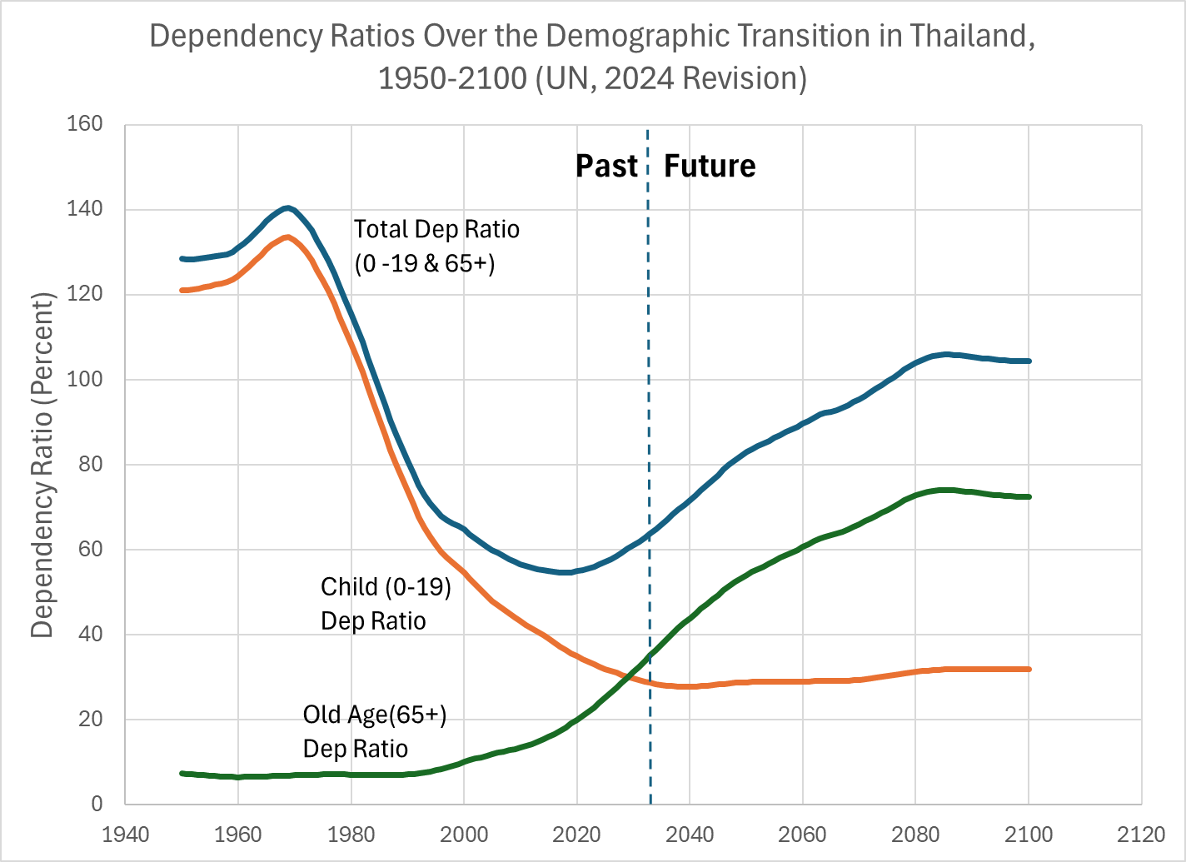

Figure I.2
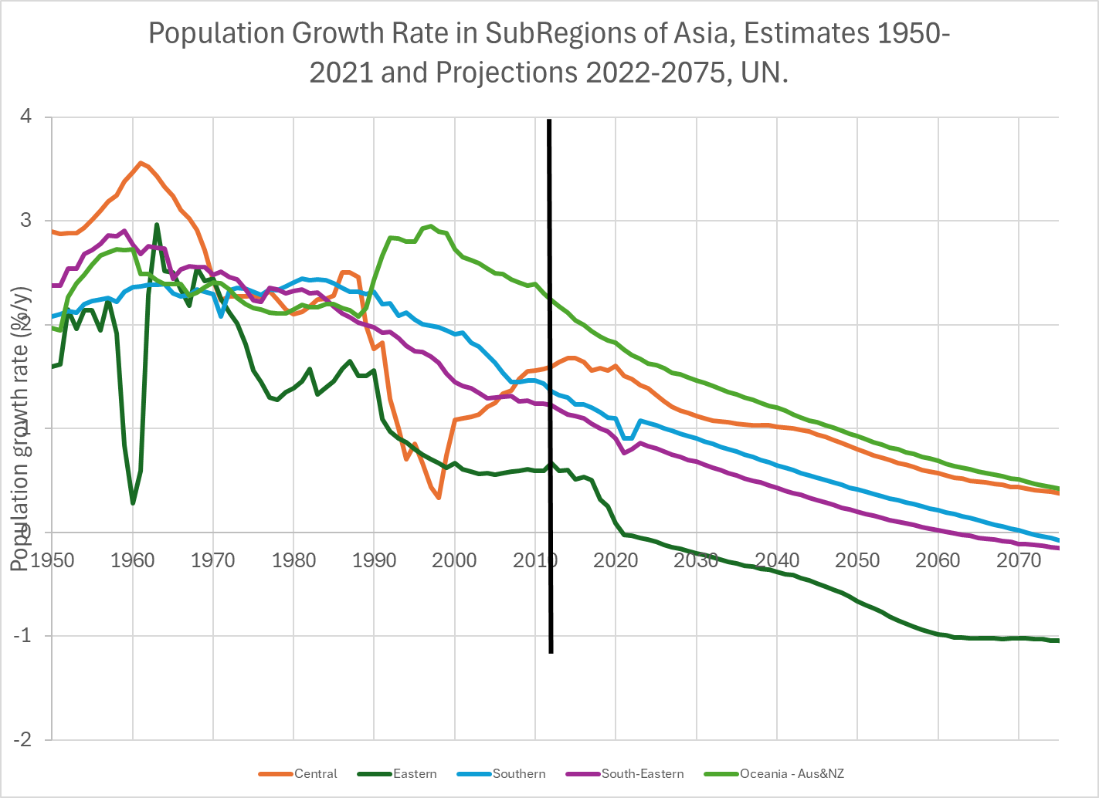

Figure II.1. NTA age profiles for labor income and consumption for 22 ESCAP countries at various dates
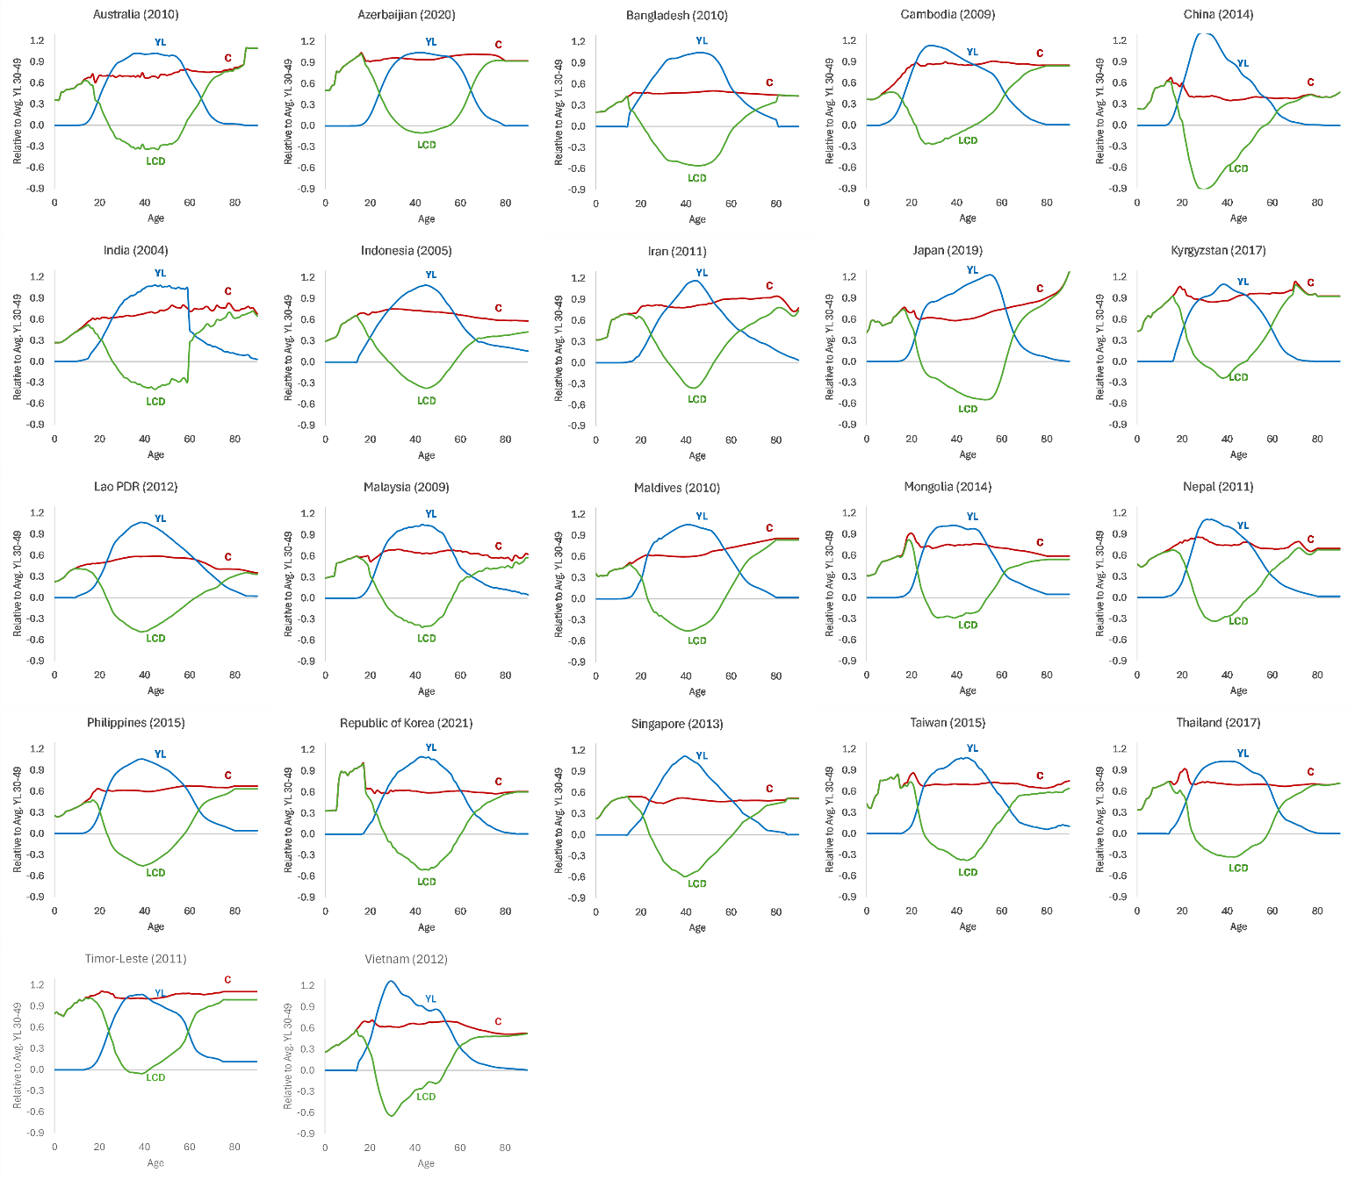

Figure II.2. Reallocations of income across the life cycle: How the gap is funded
A. Global averages for HI and UMI NTA countries 
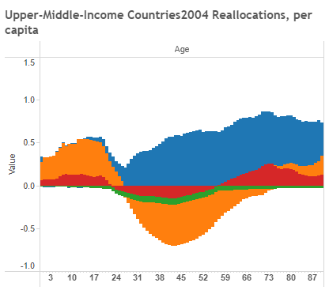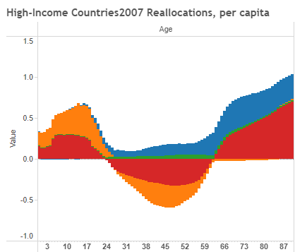
B. Changes over time in ROK and Taiwan, Province of China
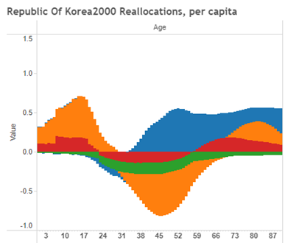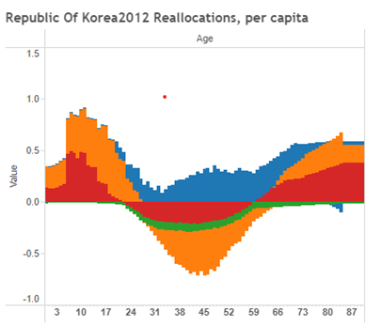
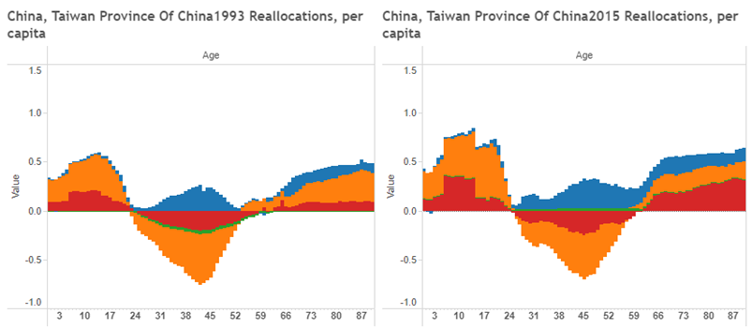
C. Reallocations in selected other ESCAP countries
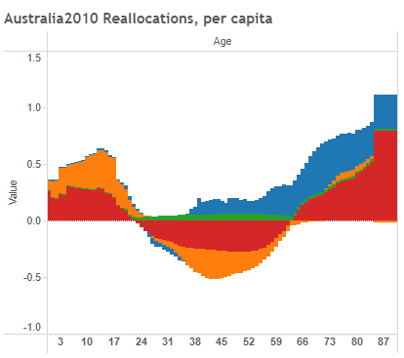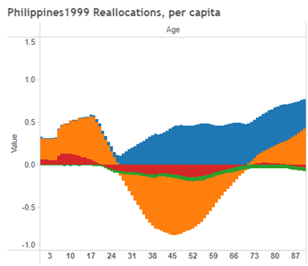
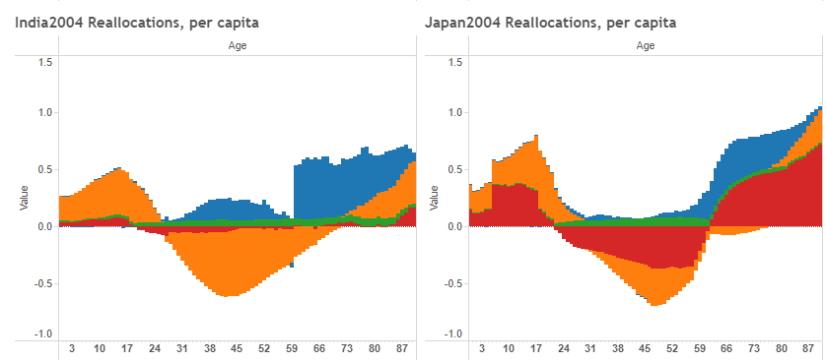

Figure III.1
Support ratios and demographic dividends -- comparative
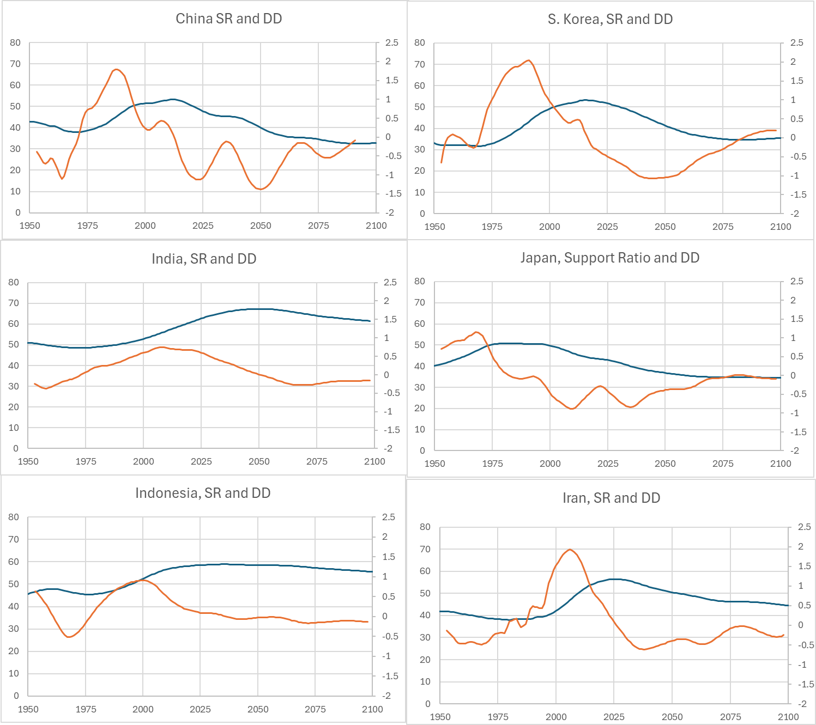
Source: Spreadsheet labeled Comp First Div, under Figures, SuppRatioGraphsAndy
These came from ntaccounts.org, NTA data portal tab, “download” in upper right hand corner of the graph it displays for each country.
URL for getting to the revised support ratios as per email from Andy:
https://ntaccounts.org/web/nta/show/Time%20Series%20Indicators

Figure III.2 Quantity-Quality tradeoff in human capital investment, public and private combined, summed 0-26 for education and 0-18 for health care, expressed in years of prime age labor income.
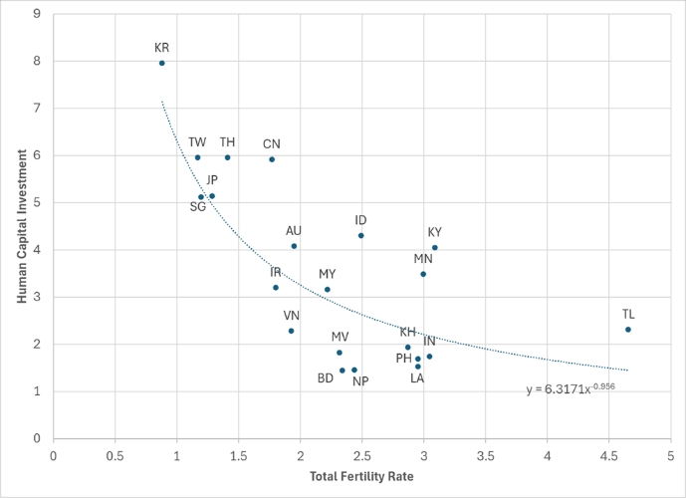

Figure IV.1 How old age consumption is financed: Percentages by asset income not saved, family transfers, and public transfers and labor income,

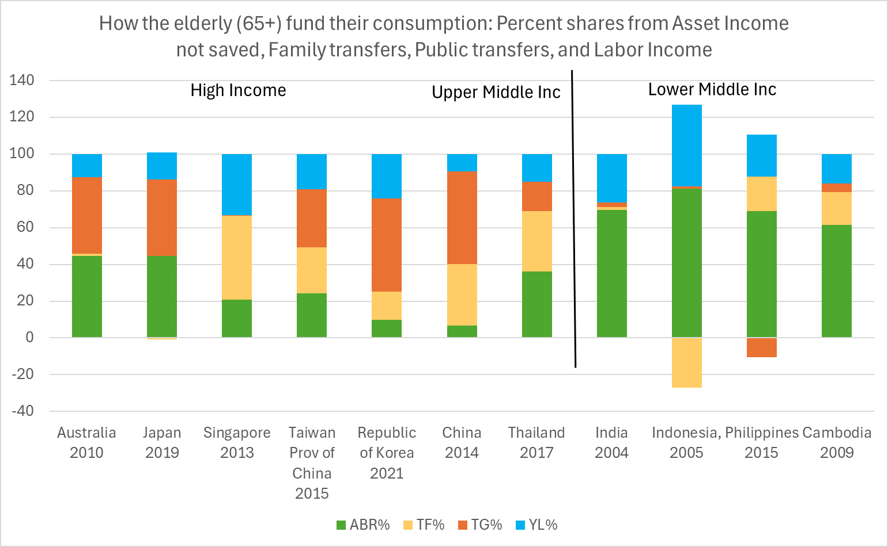
Note: “Old age” is ages 65 and above. The age profiles for consumption and the other variables are weighted by the NTA base year population age distribution and summed. “ABR” is Asset Based Reallocations, which is asset income minus savings.

Figure IV.2
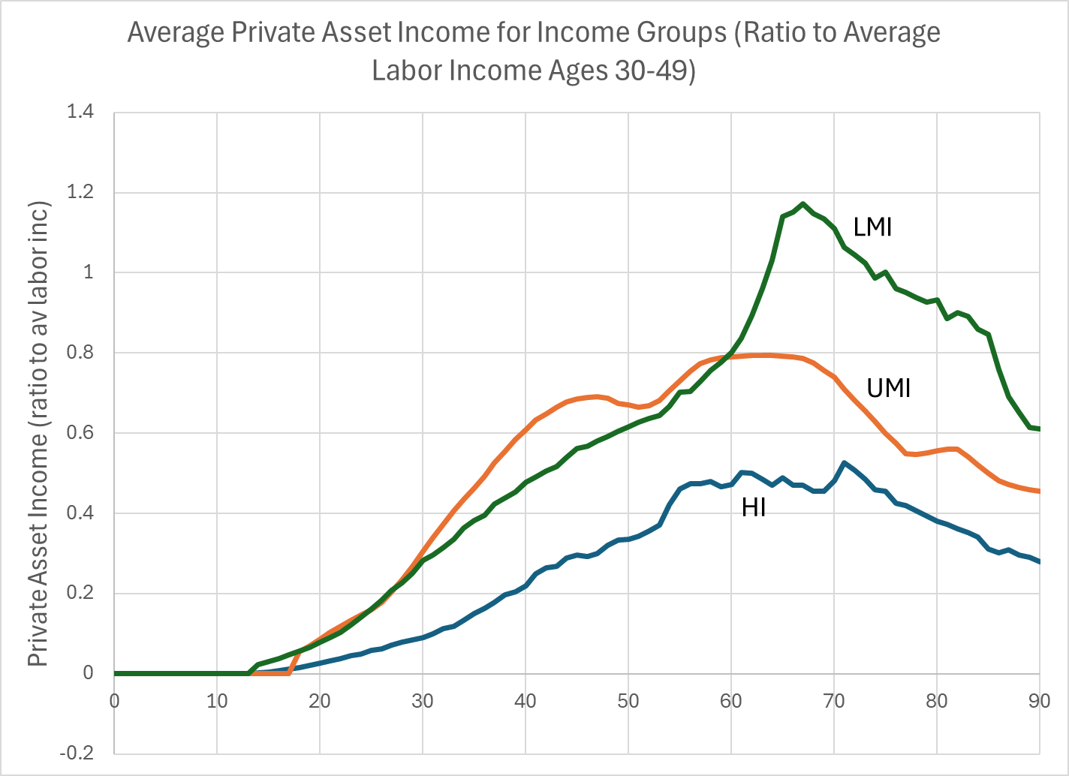
Note: HI includes Australia 2010, Japan 2019, Singapore 2013, ROK 2021, and Taiwan Province of China 2015. UMI includes China 2014 and Thailand 2017. LMI includes Indonesia (as of 2005), India 2004, and Philippines 2015.

Figure IV.3. Savings (divided by av labor income ages 30-49)
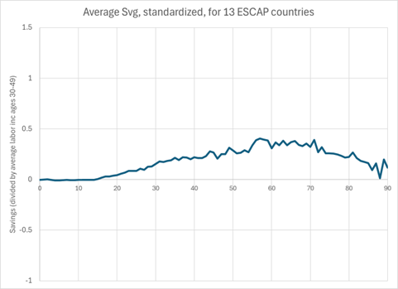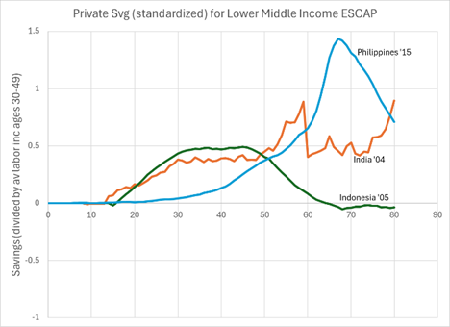

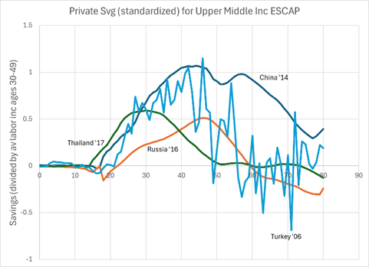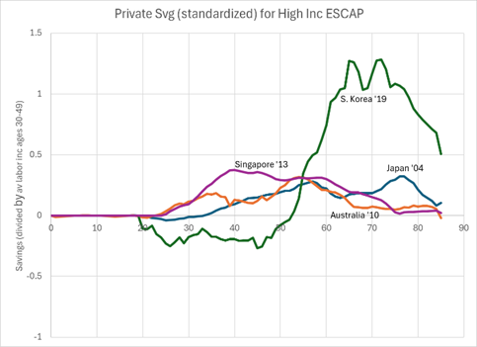
Source: NTA data for each country.

Figure IV.4. Use of asset income to fund consumption and net transfers in old age in 11 ESCAP locations. Asset-Based Reallocations (ABR), defined as asset income minus savings.
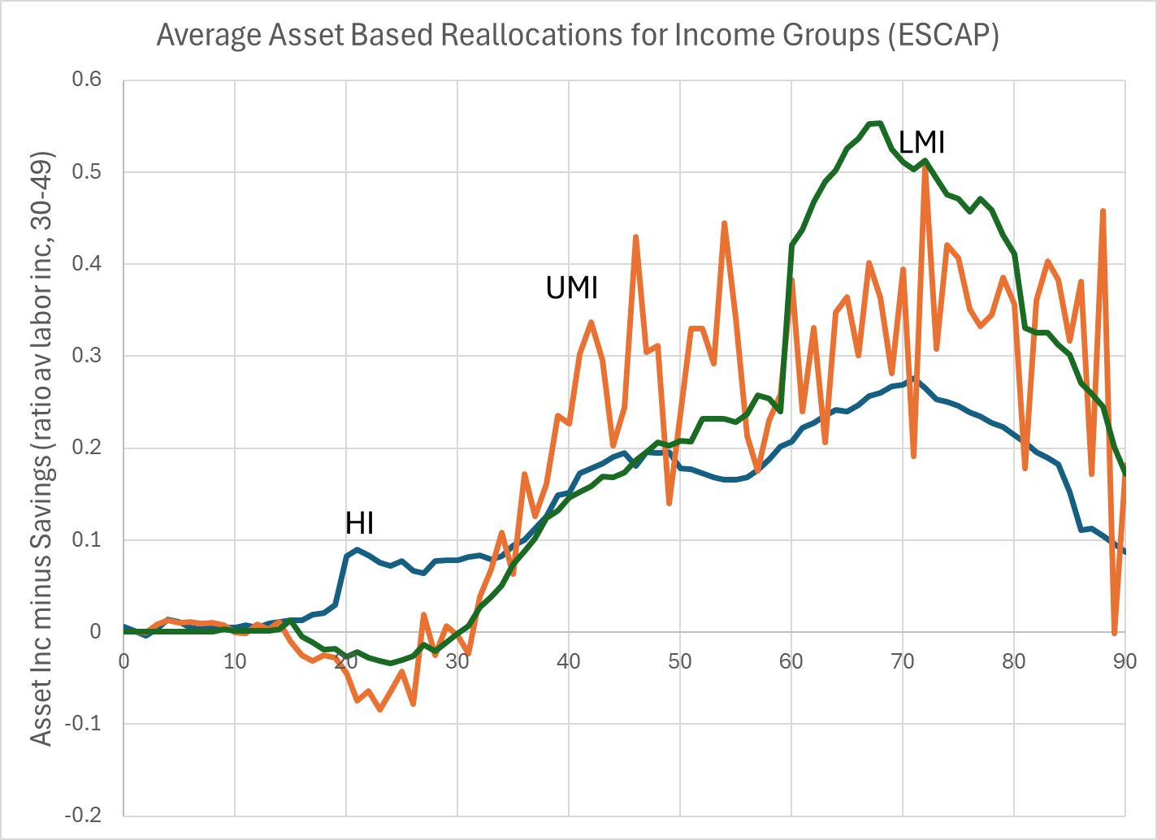
Note: HI includes Australia 2010, Japan 2004, Singapore 2013, and Taiwan Province of China 2015. UMI includes China 2014, Turkey 2006, Russia 2016, and Thailand 2017. LMI includes Philippines 2015, Laos 2012, India 2004, Indonesia 2005.

Figure IV.5 The impact of changing population age distributions on consumption per effective consumer: Standard Support ratio and General Support Ratio (takes both labor income and asset income into account) (UN 2024 Revision).
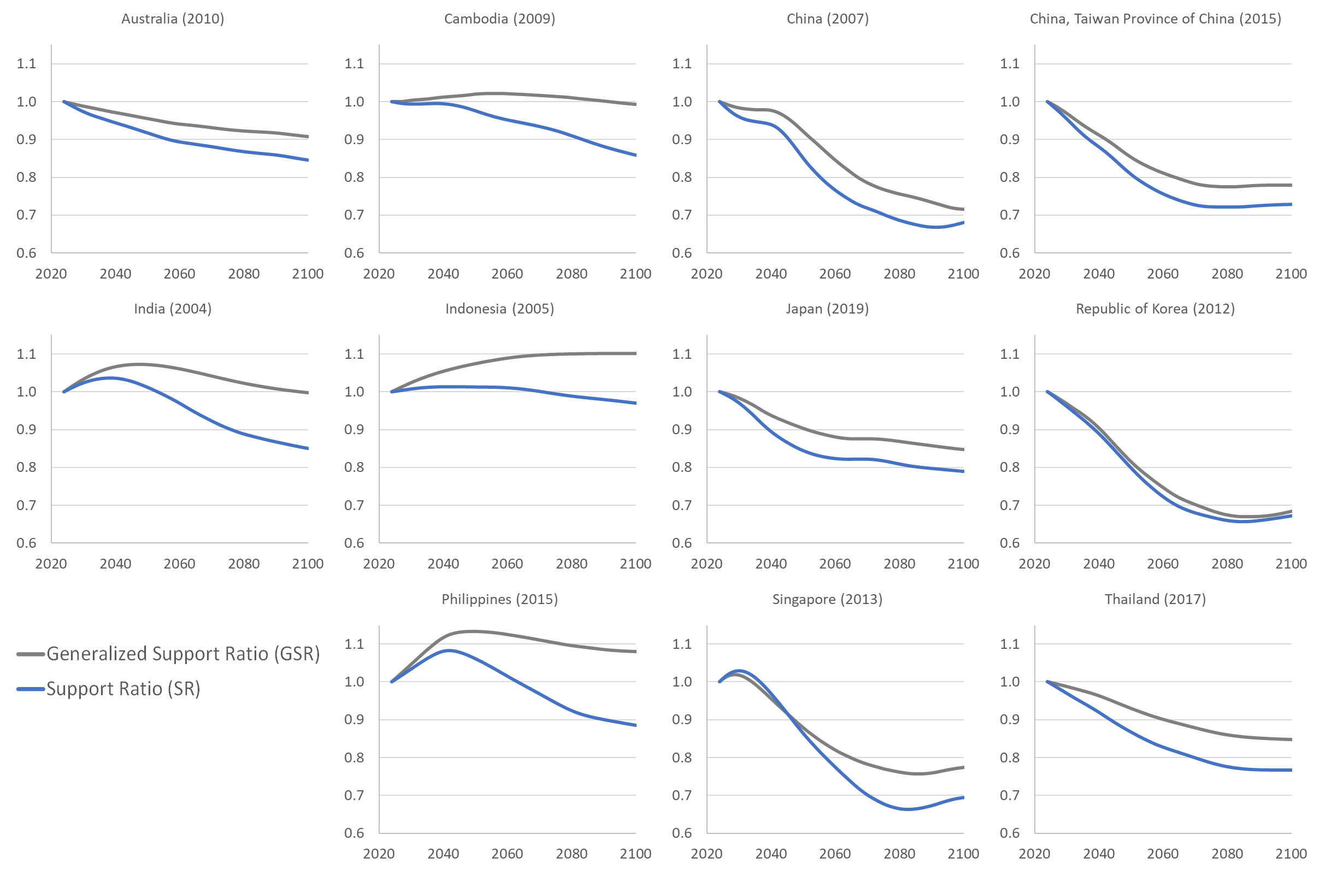

Figure IV.6. How much difference would it make to Consumption per Effective Consumer if fertility were .5 births per woman higher or lower? Support Ratio (SR) and General Support Ratio (GSR) (UN 2024 Revision; ratio to outcome with UN Medium fertility)
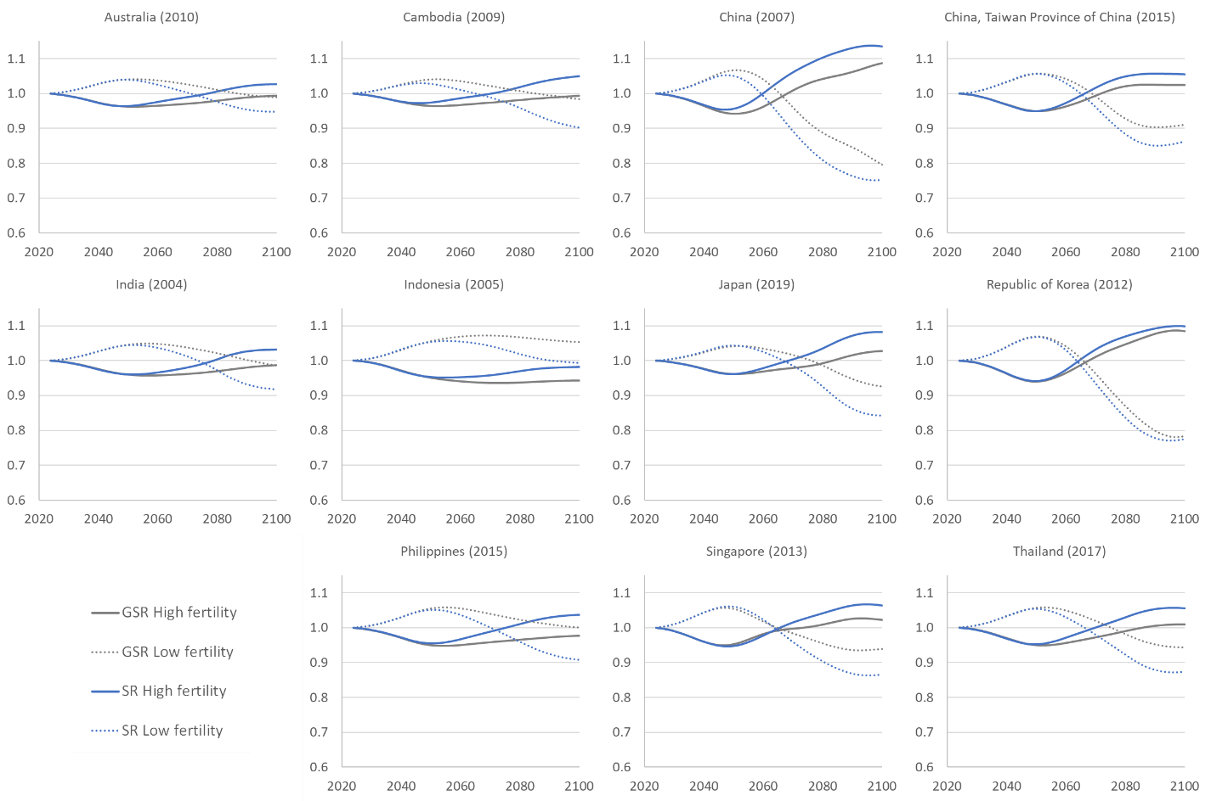
Note: This chart is based on same measures as Figure III.5, but for the SR and GSR it shows the ratio of the measure under UN High or Low fertility scenario to that under the Medium scenario.

Figure V.1 . Public and Private Transfer Systems in Selected ESCAP Countries: Inflows (transfers received), Outflows (transfers given), and Inflows minus Outflows (Net)
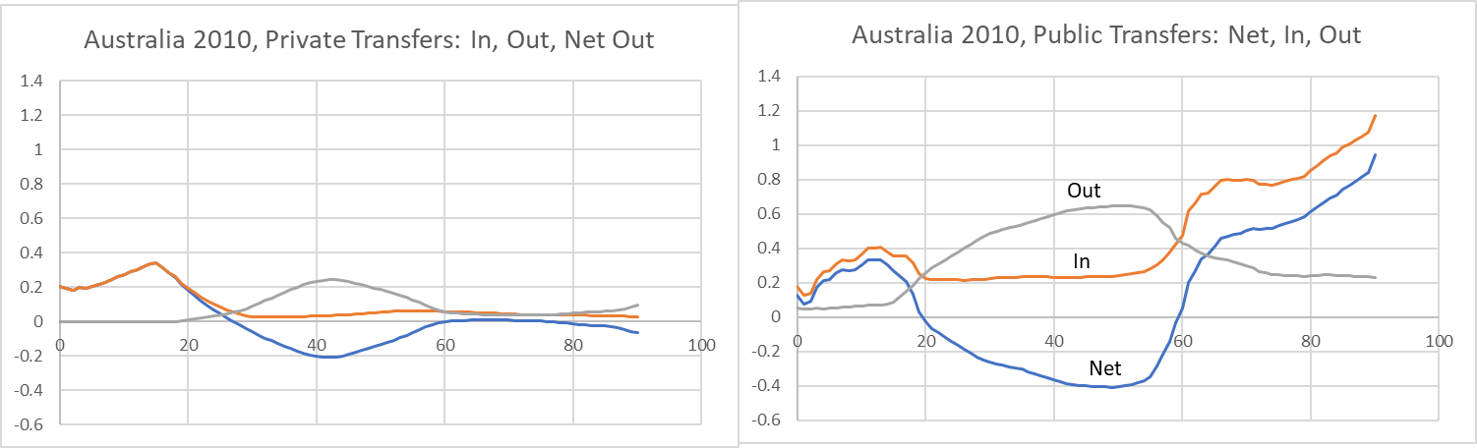
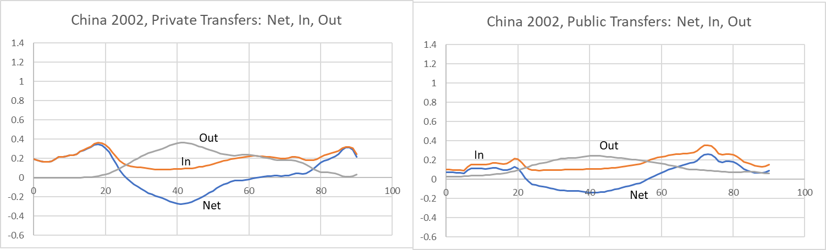
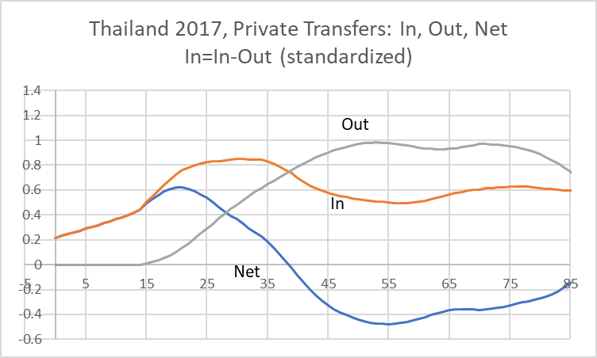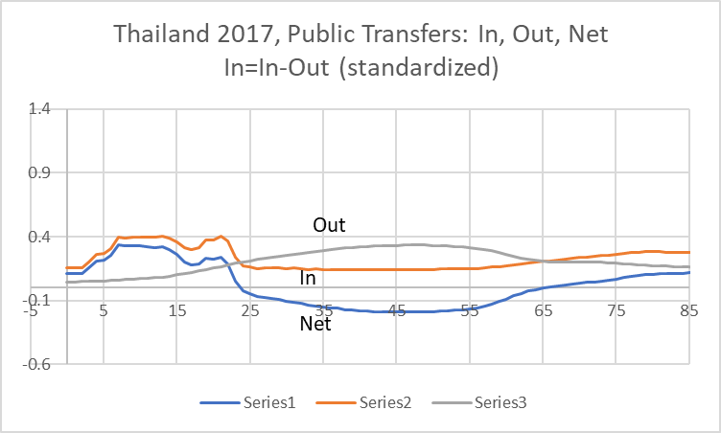
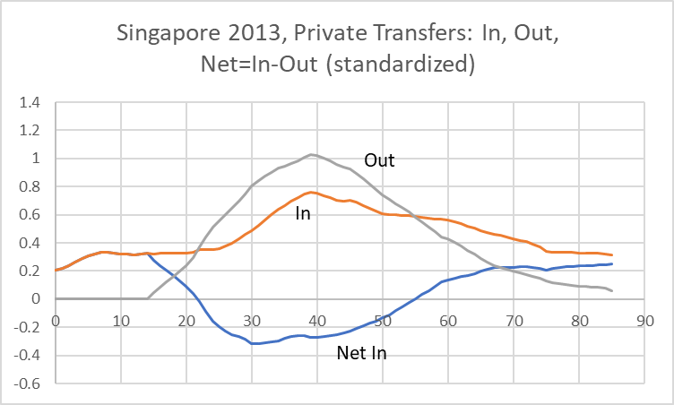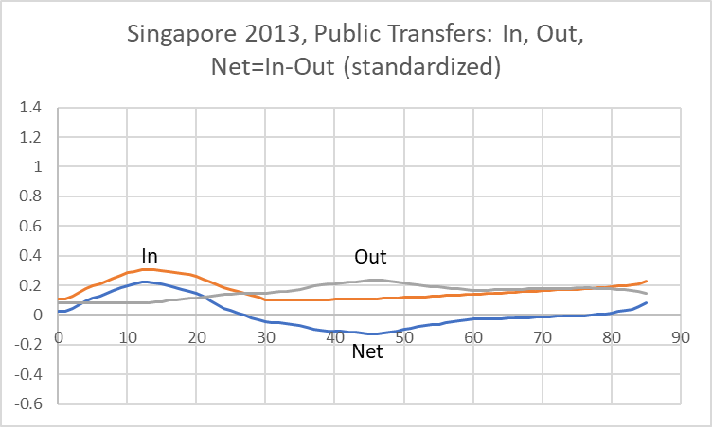

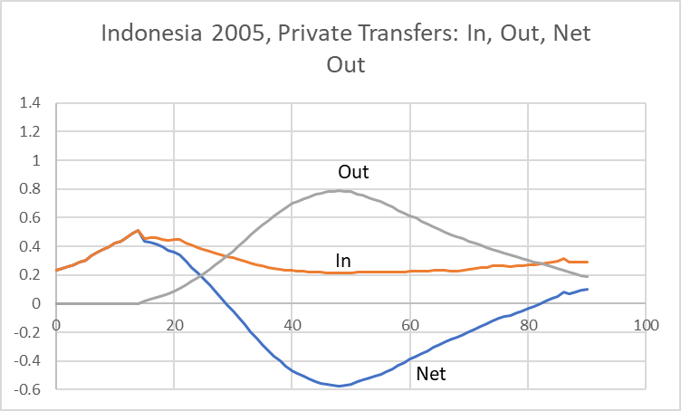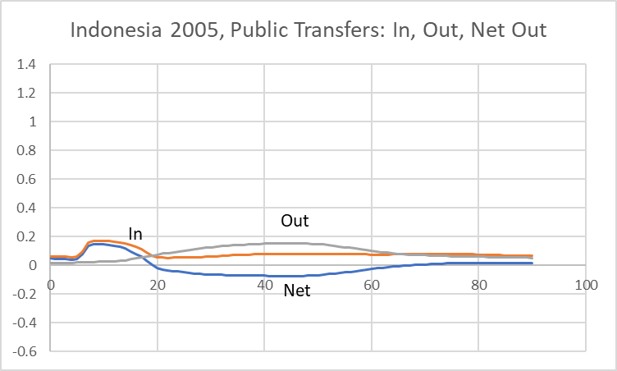
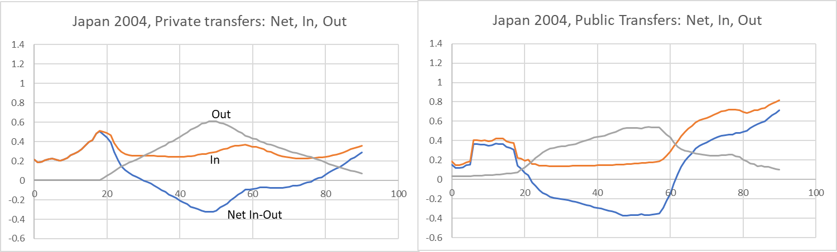
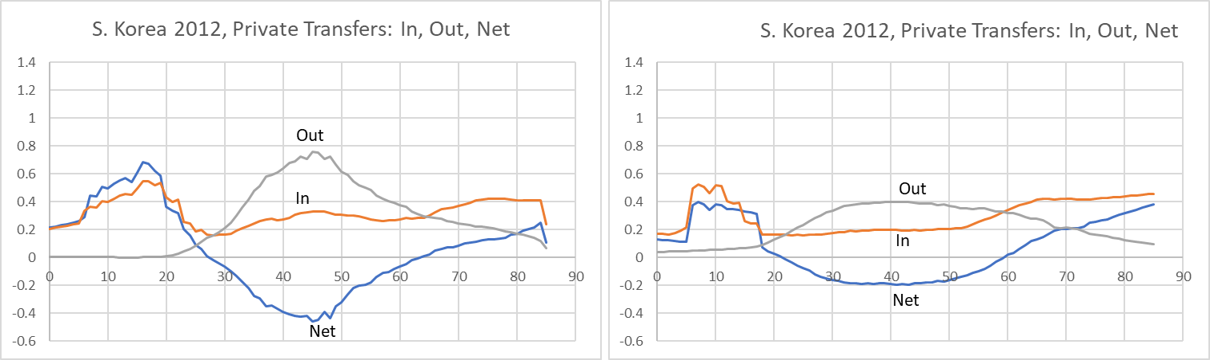
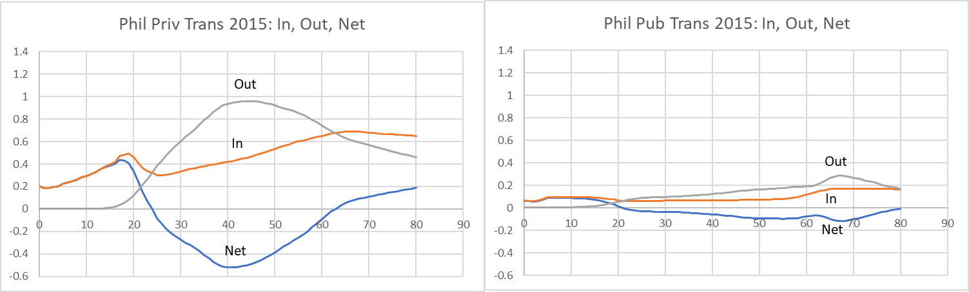
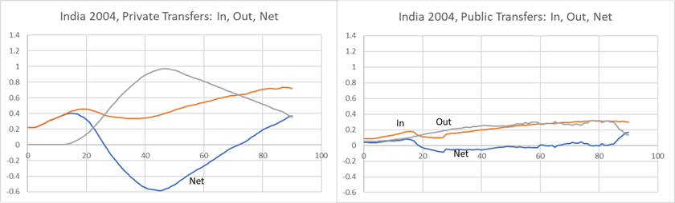
Figure V.2 Fiscal Support Ratios for 11 ESCAP countries, 2024-2075, Indexed to 1.0 in 2024. By UN fertility scenario: Red=High; Blue = Medium; Green=Low.
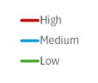
Note: The dates of the NTA baseline data used for these projections are as follows: Australia 2010, Azerbaijan 2020, Cambodia 2009, China 2014, India 2004, Japan 2019, Lao PDR 2012, Philippines 2015, Singapore 2013, South Korea 2012, Taiwan Province of China 2015, Thailand 2017.

Figure V.3 How public transfers have changed over time (inflows, i.e. benefits received), standardized
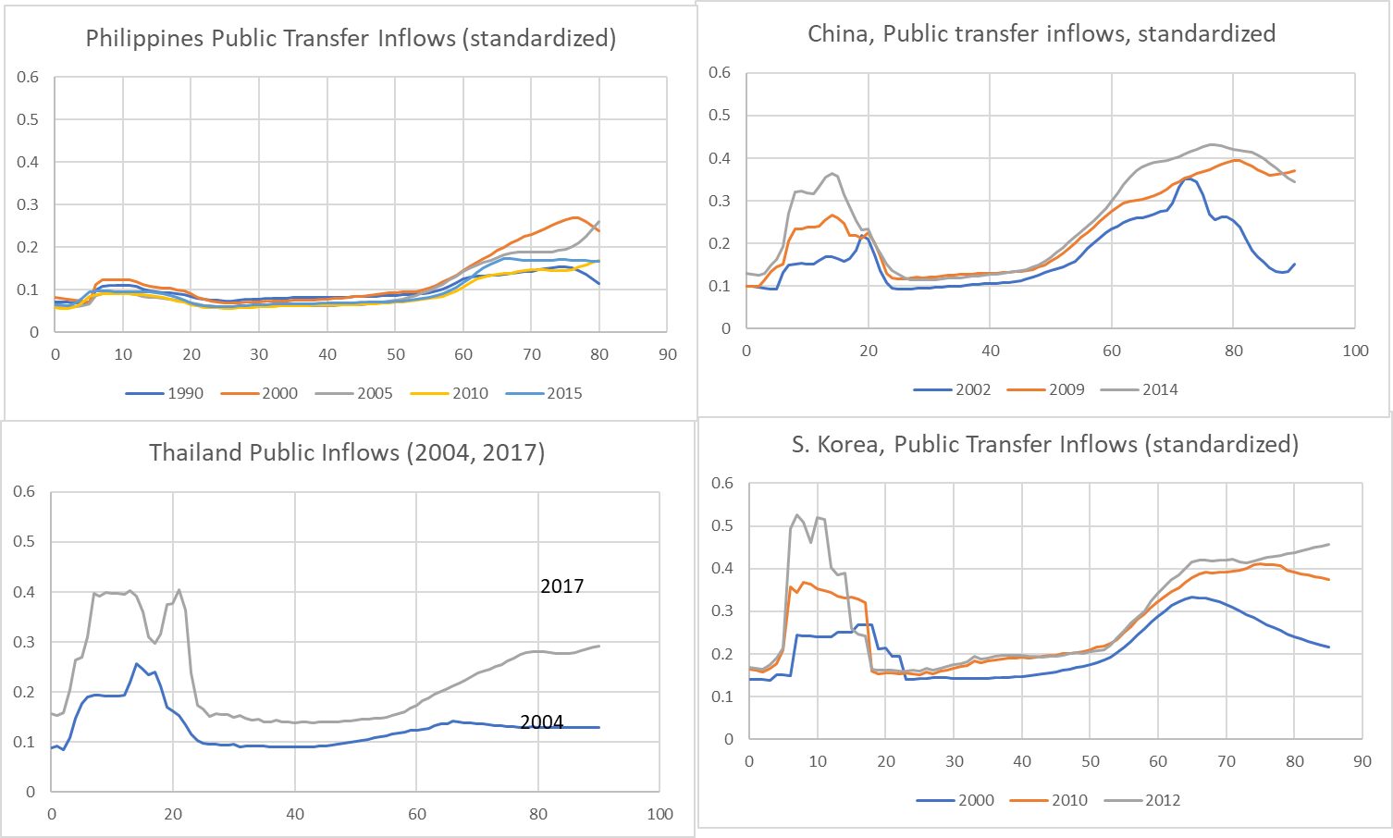

Figure VI.1 How familial transfer systems have changed over time – various measures of net and gross flows
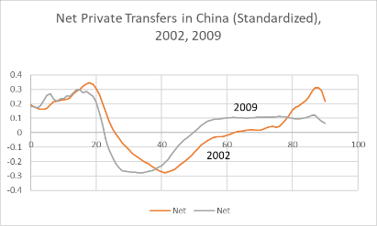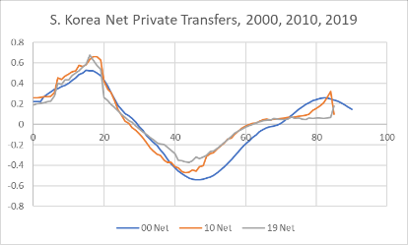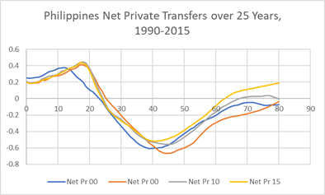
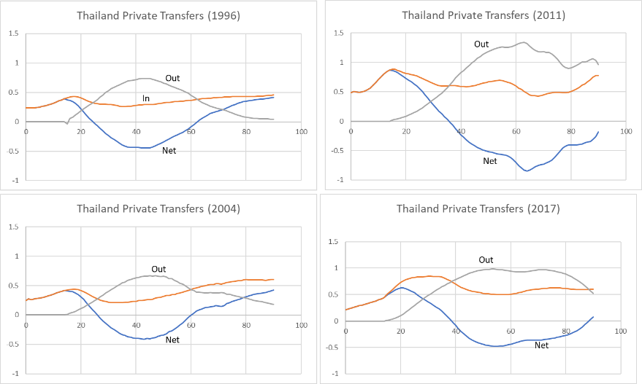
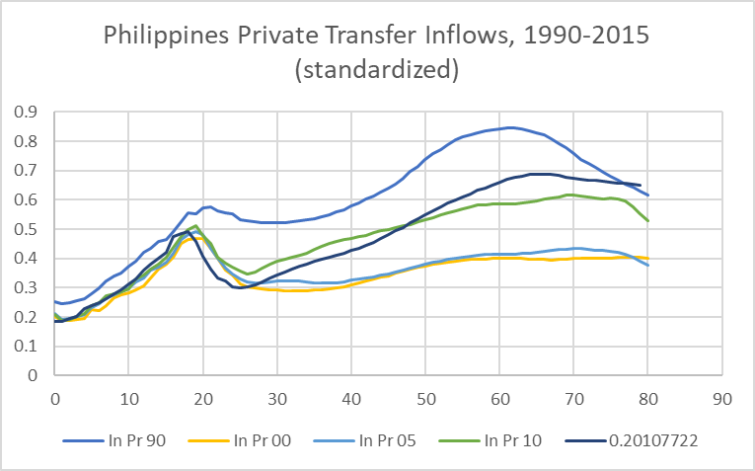

Figure VI.2 Familial Transfer Support Ratios under High, Medium, and Low Fertility Projections (United Nations 2024 Revision).
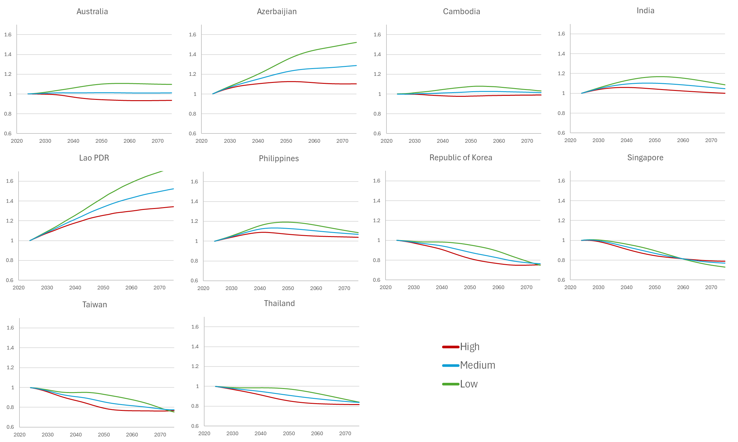
Note: The Familial Support Ratio is the ratio of the population-weighted familial transfers received to the population-weighted familial transfers given, indexed to 1.0 in 2024.

Figure VII.1 Public, Private, and Total Transfer Loads (Effective net transfers/effective consumption)
A. Public Transfer Load B. Private Transfer Load
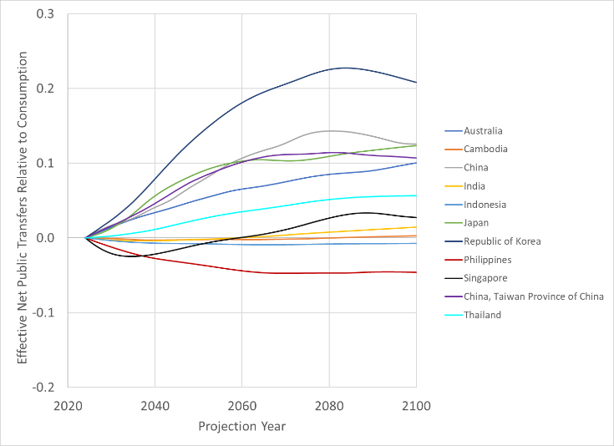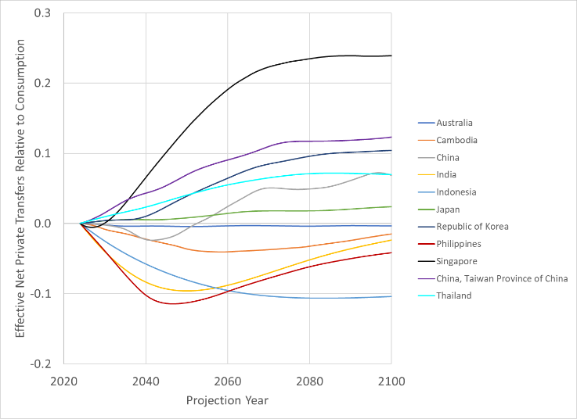
C. Total Transfer Load (Public plus Private)
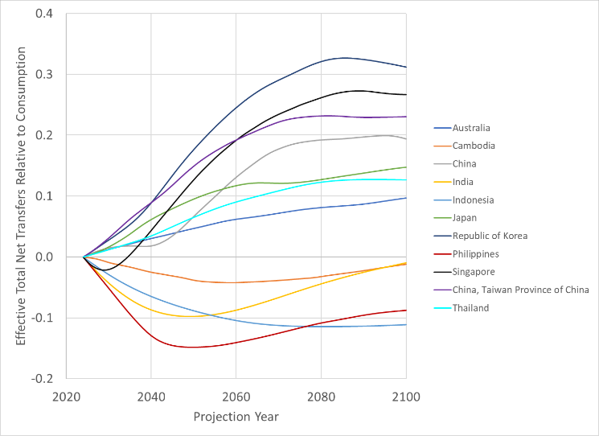
Note: Effective net transfers and effective consumption are the population weighted sums of the respective age profiles. In an economy without transfers to and from other countries in the base year (here 2024) each of public, private and total effective transfers would be identically equal to zero. However, some countries such as the Philippines receive important net transfers from abroad, and some receive or give foreign aid. Also, none of the NTA for any of these countries was estimated for a 2024 base year, and many were estimated many years previous. In this case when the 2024 population age distribution rather than the true baseline population age distribution is used to calculate the effective net transfers the result will not be zero. Nonetheless, the effective totals have been set equal to zero in 2024 in order to show most clearly the projected effects of the changes in population age distributions after 2024.

Figure VIII.1 An important component of the parent’s “price” of a child: Private spending on education from birth to age 26 in NTA ESCAP countries relative to labor income
